How to Create a New User Account

1. Select either the “New Users: Register for an Account” or “New Request” to get started.

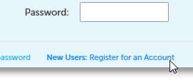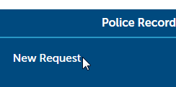

If you select “New Users: Register for an Account” - Skip to Step 3
If you select “New Request” - Continue to Step 2

2. Click the “Register Now” button.

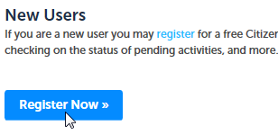

3. Please read and accept the Terms & Conditions.

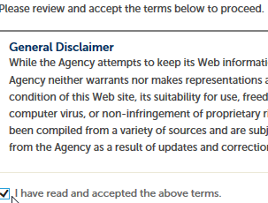

4. Click the “Continue Registration” button

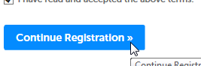

5. Under the “Login Information” Section, create a User Name for the account.

6. Under the “Login Information” Section, enter you primary email address for the account.

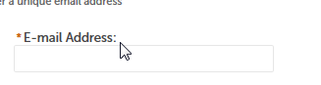

7. Under the “Login Information” Section, create a Password for the account. It should be 8-20 characters in length.

8. Under the “Login Information” Section, create a Create a Security question and answer for the account.

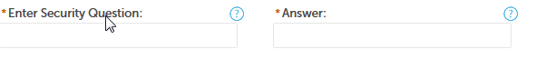

9. Under the “Contact Information” Section, click the “Add New” button.

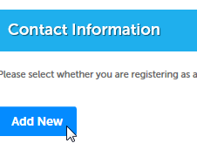

10. Select what type of contact you are creating. You can register as either a person or a company.

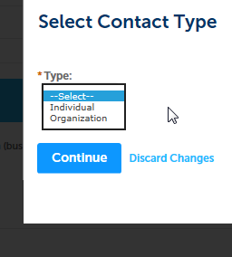

Once you click the “Continue” button. Please note the information entered will be the address or email address that the requested records will be returned to.

11. Enter the Captiva information as displayed on the screen. And click the “ Continue Registration” button.

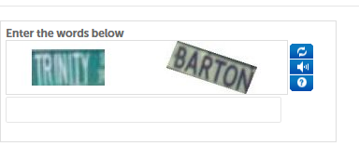

12. You have now created your new account! To login to your account, please select the “Login” link in the top right corner of the screen.

