HOW TO REQUEST A POLICE RECORD

1. After you have created your account, enter you User Name and Password and click the ”Login” button.

2. You are now at the initial Dashboard Screen. Select the “Police Records” from the navigation menu.

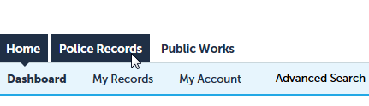

3. This screen will show any request that you have made and their status. To place a new request, select the “New Request” option.

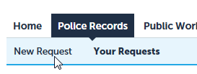

4. Please read the disclaimer and check the acknowledgement box. Next, click the “Continue Registration” button

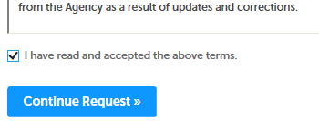

5. Add your requestor information. You can do this from the contacts you entered when you created your account or add a new requestor.

If you choose “Select from Account”:

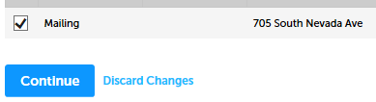
Select the box for the desired requestor and click the “Continue” button.

If you choose “Add New”, you will be prompted to add the persons contact information.

6. With the requestor added, click the “Continue Request” button.

7. You are now in the request form.

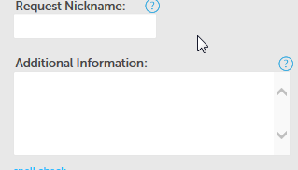 | These fields are for you use. You may give the request a name for your records. The second field is for providing any information that you feel may relevant to locating your requested records.
 | This field is primarily used by insurance companies or attorneys to reference an internal tracking number.
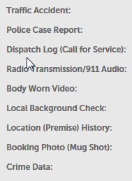 | Select the type of police record you would like to request. If your record is not shown please select “Crime Data” and provide a detailed description of the records you are requesting.  Depending on your selection, you will next be prompted to provide additional search information. Please fill in as much information as you know. This helps ensure we can quickly locate the records you are requesting.
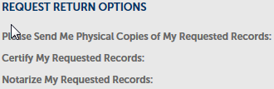 | All police records are generally returned electronically via this system or City of Colorado Springs email. If you require special processing, please select the appropriate option.

**If you are requesting either your juvenile records or the juvenile records of your minor child, you will need to provide additional information in Step 9. **

8. Once you have completed filling in the form, click the “Continue Request” button.

9. On this screen you can attach documents to your request. If you are requesting your juvenile records you will need or attach a copy of our government issued photo ID. The release of juvenile records is highly restricted by Colorado state statute. If you are requesting the records of you minor child, you will need to attach proof of parentage (birth certificate, adoption paperwork, guardianship paperwork, or other court documents) and your government issued photo ID. Without these documents your request may be denied.

To add a document, click the “Add” key and follow the onscreen directions.

10. Once you have completed attaching documents to the form, click the “Continue Request” button.

11. You can now review you request prior to submittal. You may edit any portion of the request by selecting “Edit” button for the field.

12. Once you have reviewed your request, please read and acknowledge, by checking the box, the pecuniary (financial) gain statement.

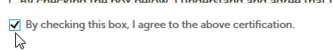

13. Click the “Continue Request” button to submit your request.

Record Processing Status Definitions

When you log in to your account, you are able to see the workflow “Status” of your request. The status definitions are as follows:

STATUS | DEFINITION
Additional Information Requested |  | Your request has been pended, and requires additional information before in can be processed.
Assigned |  | Your request has been assigned to a Technician for processing.
Cancelled |  | The request has been cancelled by the requestor.
Completed |  | Final status for a request once all fees have been paid.
Completed- Fee Paid |  | The records are available for download and all fees are paid
Completed- Fee Waived |  | The records are available for download and all fees are waived.
Completed-Charge to Account |  | The records are available for download and all fees have been charged to account.
Completed-Payment Pending |  | The records are available for download once the fees are paid.
Completed-Pre Paid |  | The records are available for download and all fees are paid
Denied |  | The requested records cannot be released.
Pending Internal Review |  | The request is undergoing additional research prior to release or denial.
Processing |  | The request is currently being processed for release.
Submitted |  | Your request has been received by the Record Release Unit and is pending review and assignment to a technician by a supervisor.

