ACA Online Application How-To: Contractor

- Register or log in.
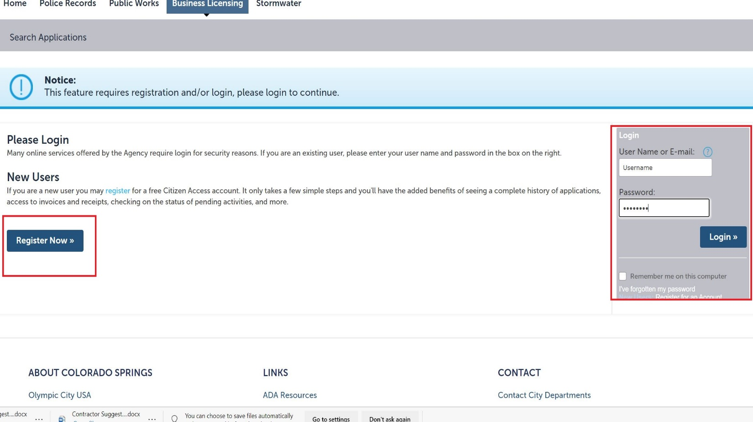

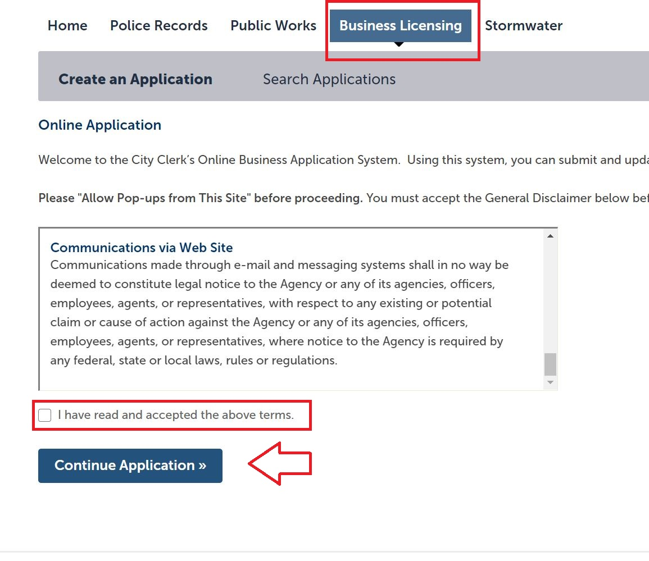
- Under the Business Licensing tab, agree to the terms and conditions prompt and click Continue Application.

- Choose Contractor Application and click Continue Application.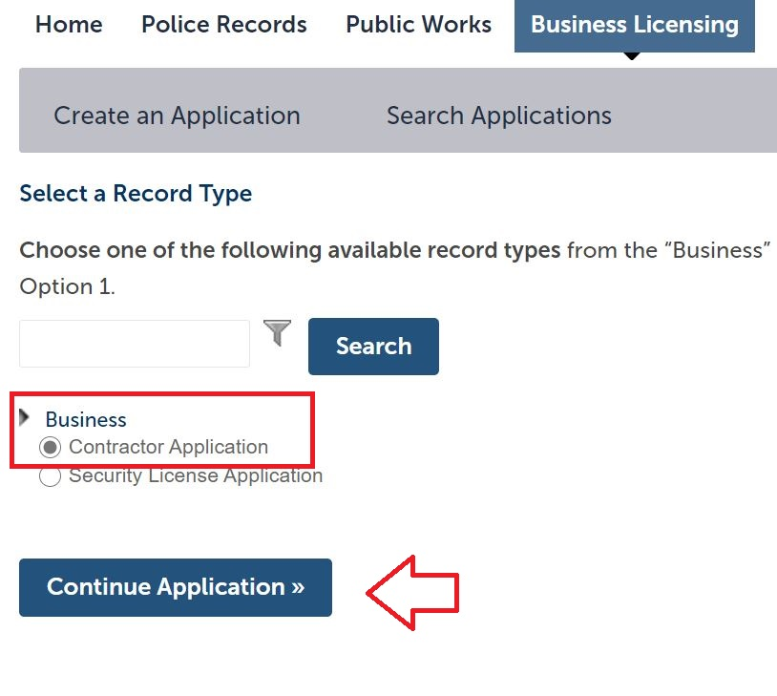
- In step 1 of the application flow, enter the company’s business trade name in the Business Name/Applicant Name field.
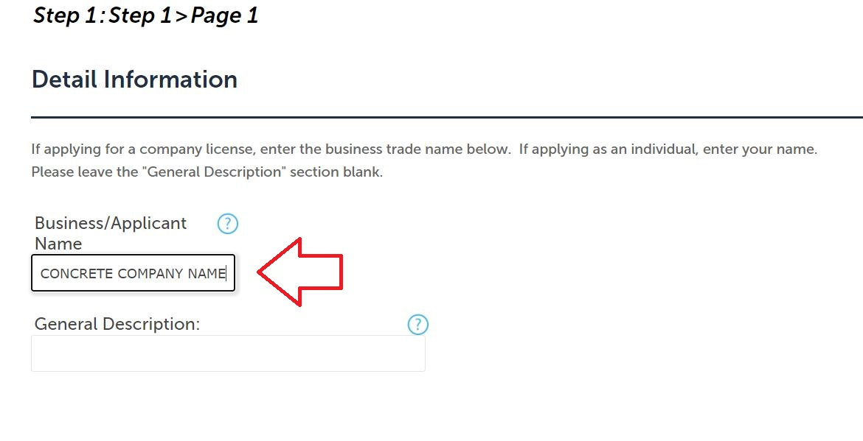

- Add the company information as a contact in the next step under the Applicant option.
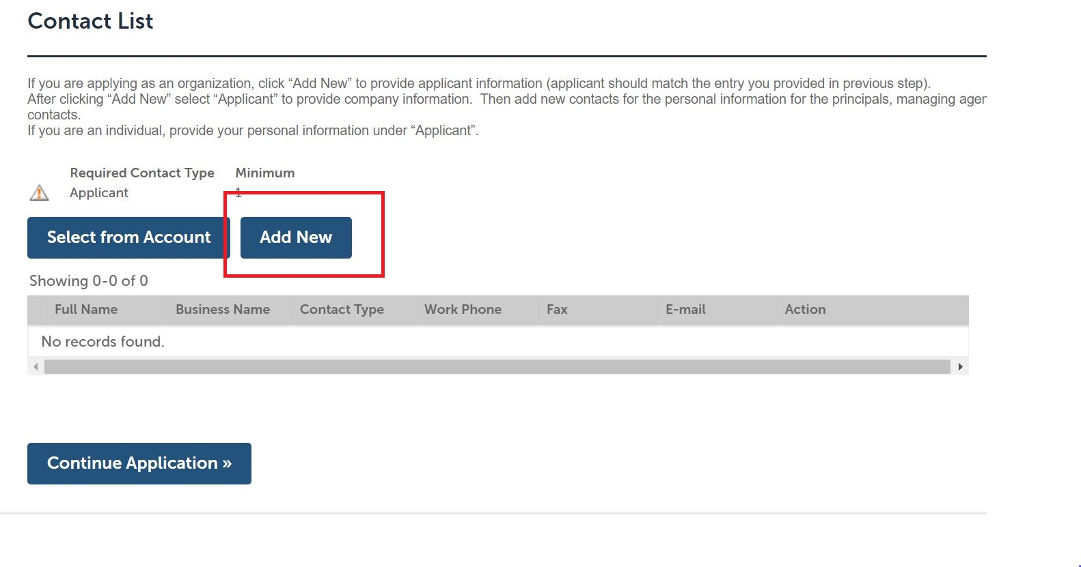

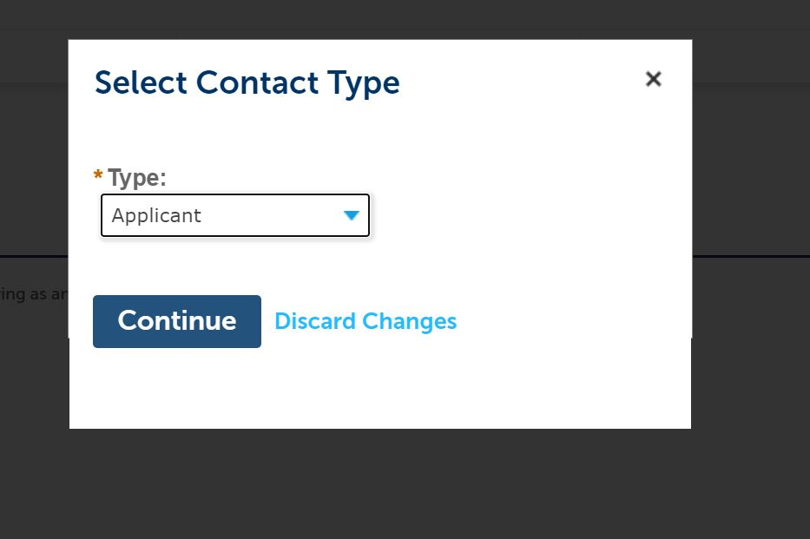

- Add all additional relevant principals, managing agents, and the registered agent for service in the same fashion, ensuring personal (as opposed to business) information is provided for all individuals. If the personal details for any of the individuals listed here is on file from when you registered the account, you may import their data here by clicking the Select from Account option.
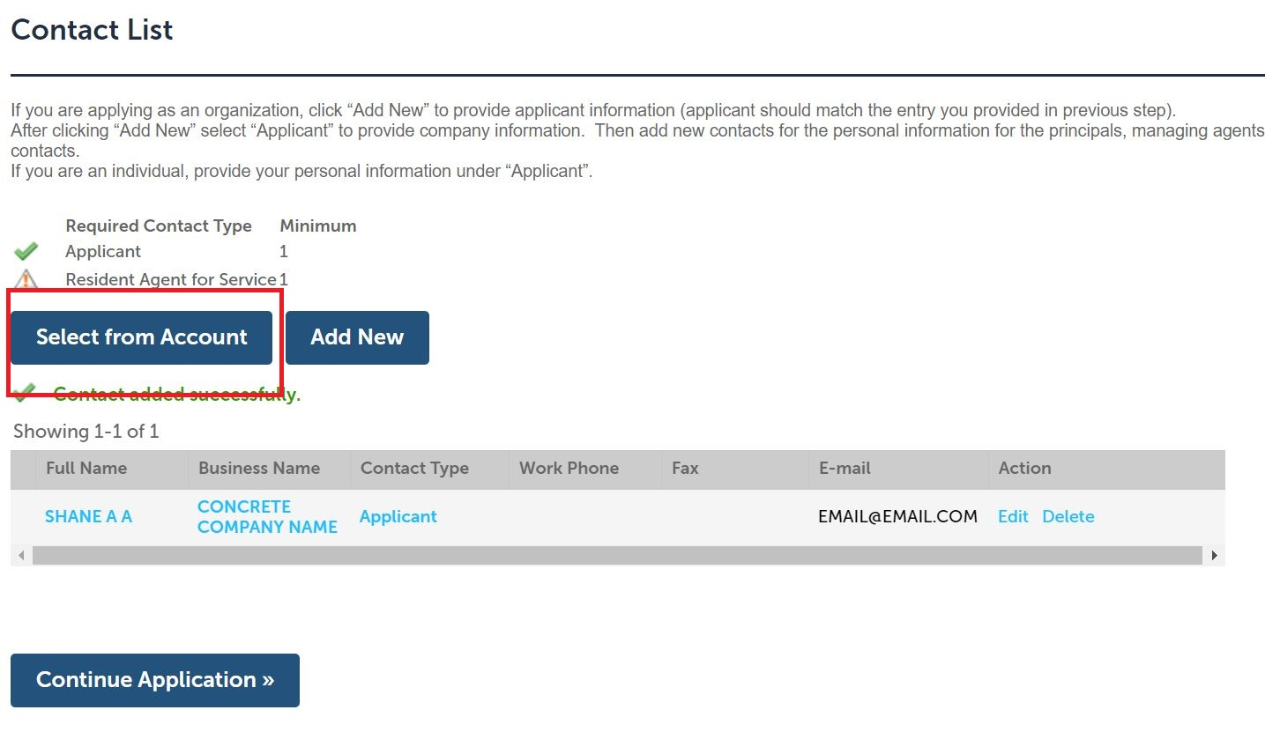

- Select which license type for which you are applying from the Type of License drop-down menu, and answer the questions in the Custom Fields step of the application flow.
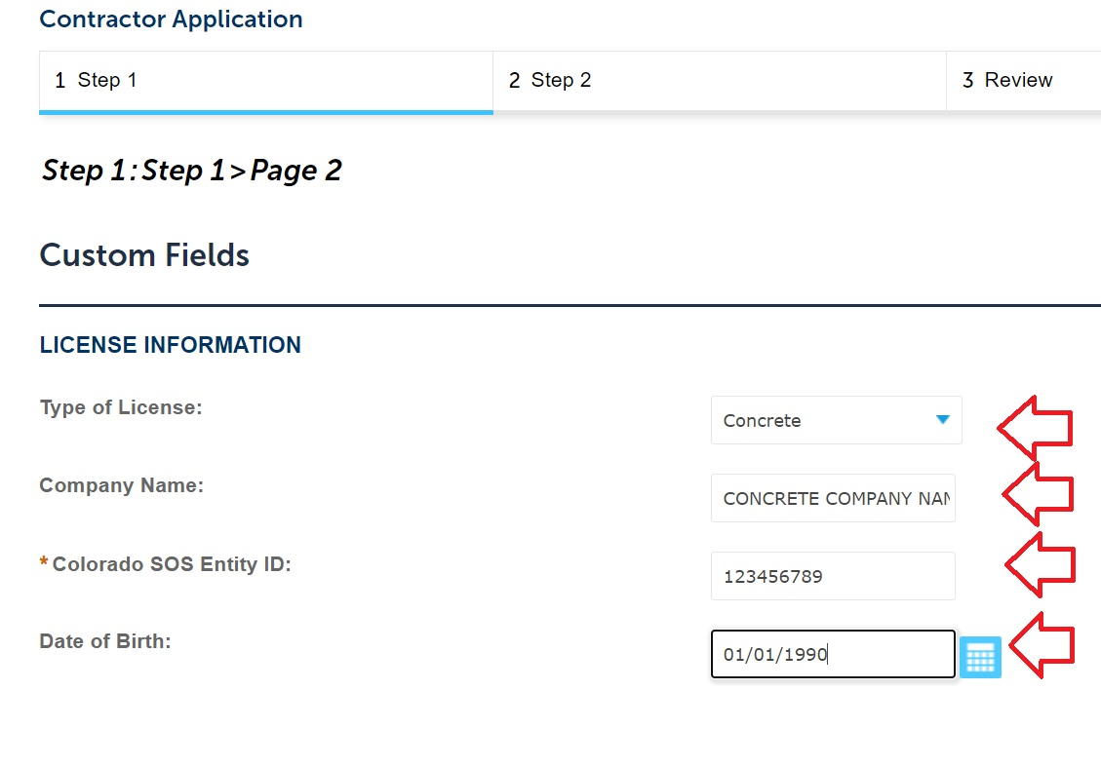

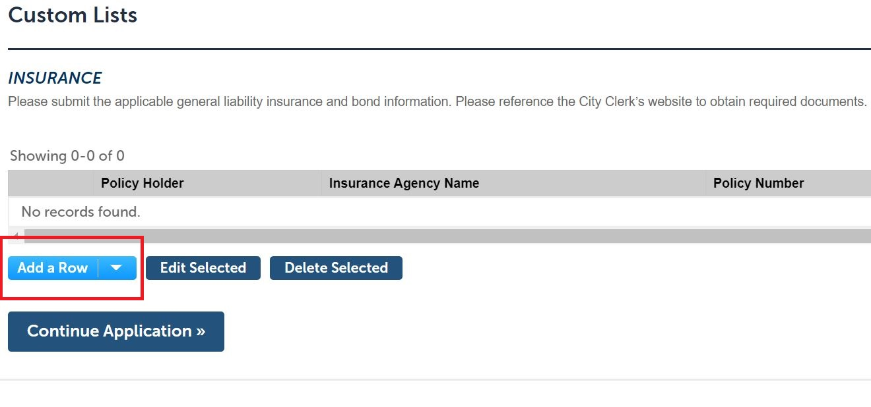
- In the Custom Lists fields, provide the details for the general liability insurance and bond policies by clicking Add a Row for each policy. The bond expiration date should read 01/01/2001, provided you have the proper City-approved bond form.

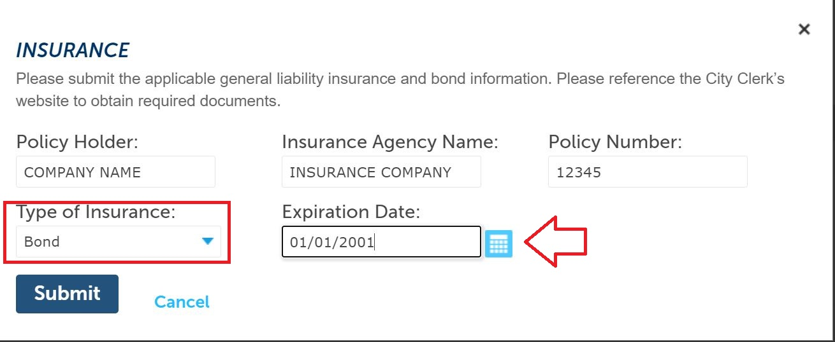

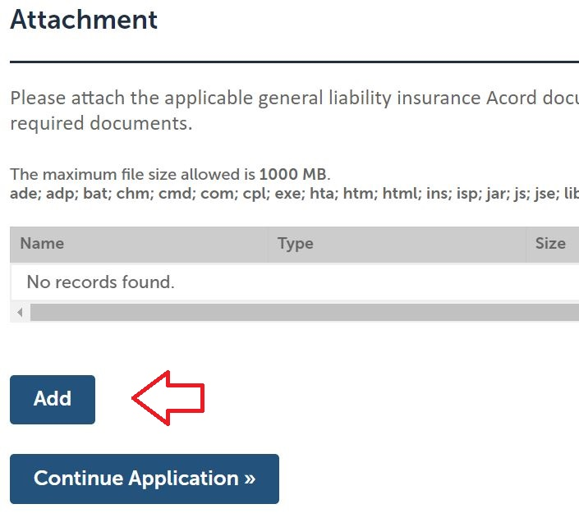
- In step 2 of the workflow, click Add to attach the insurance Acord document, ensuring the City is included as Certificate Holder; the City-approved bond form; the Secretary of State Trade Name Registration and/or Certificate of Good Standing, the Lawful Presence Affidavit, if applicable; and any other required documentation.

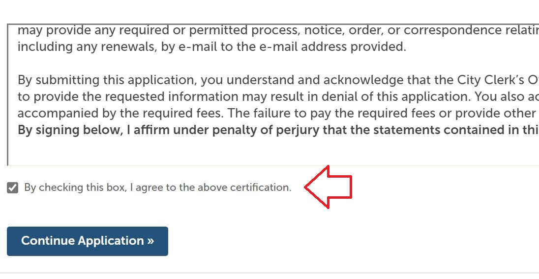
- In step 3 of the workflow, review all information for accuracy. At the bottom of the page, read the language in the certification window, and check the box below it to confirm you understand and agree. Then move forward by clicking Continue Application.

- In step 4 of the workflow, review the payment information for accuracy, and click Check Out. The next screen will review all items in your cart. Click Checkout again to move forward with paying the license fees.
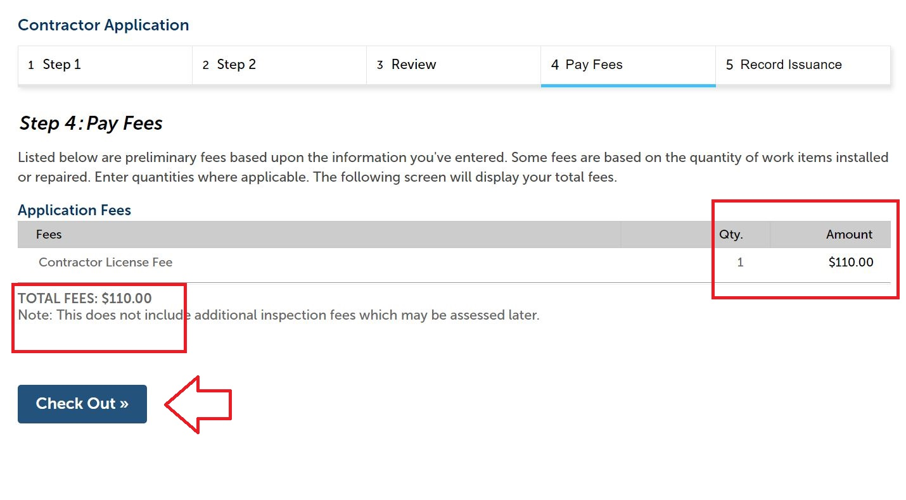

- Submit payment details and click Submit Payment to finalize.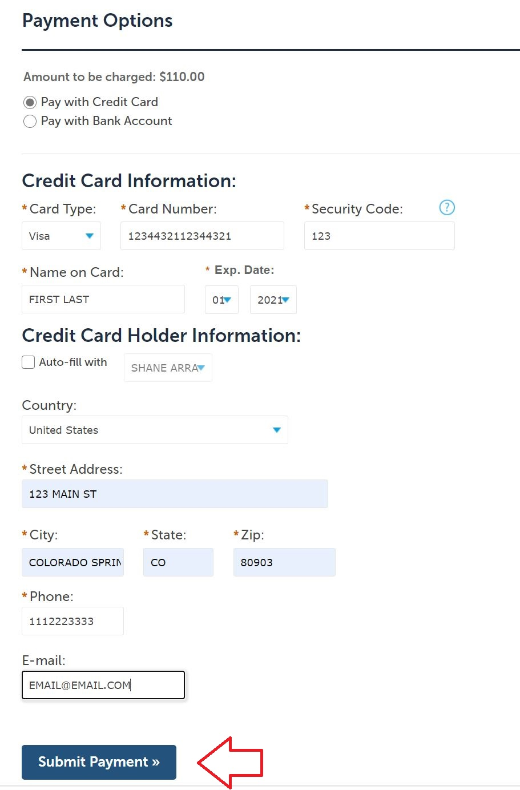
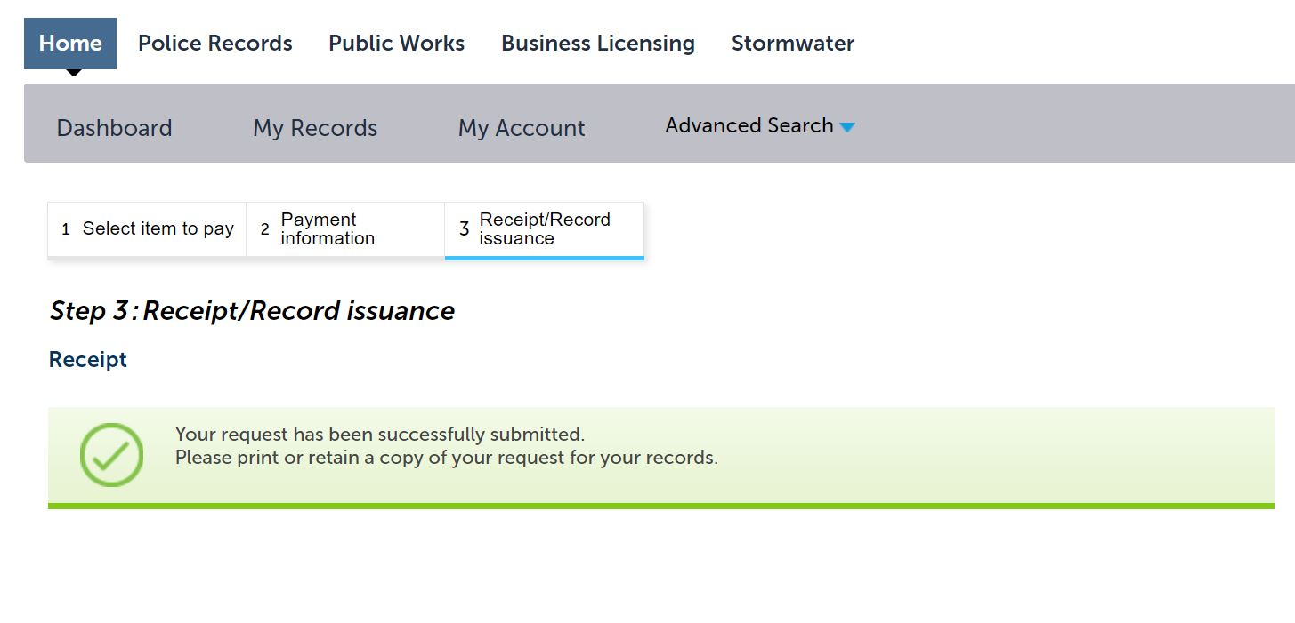
- Once you receive payment confirmation, the application has been sent to the City Clerk’s office for review. Please note, the license is not yet issued at this stage. If any additional information is required, City Clerk general business licensing staff will contact the e-mail address provided for the Applicant. Otherwise, the license will be issued by City Clerk staff and mailed to the address provided for the Applicant.

