ACA How-To: General Business Licenses

- Register or log in.
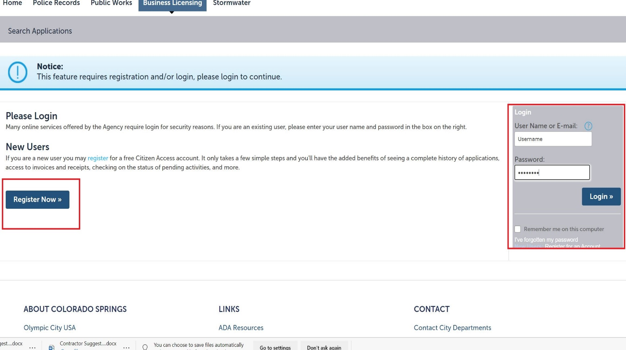

- Under the Business Licensing tab, agree to the terms and conditions prompt and click Continue Application.
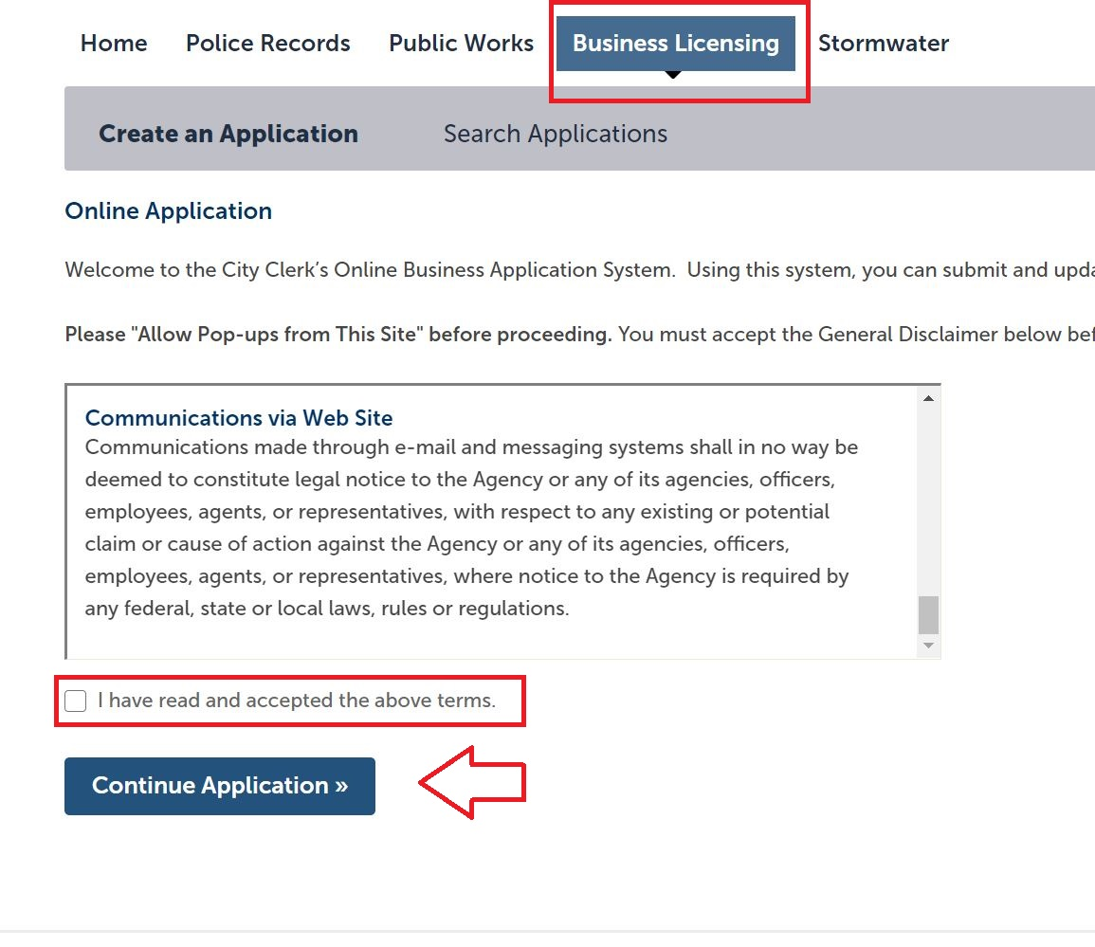

- Choose General Business Application and click Continue Application.
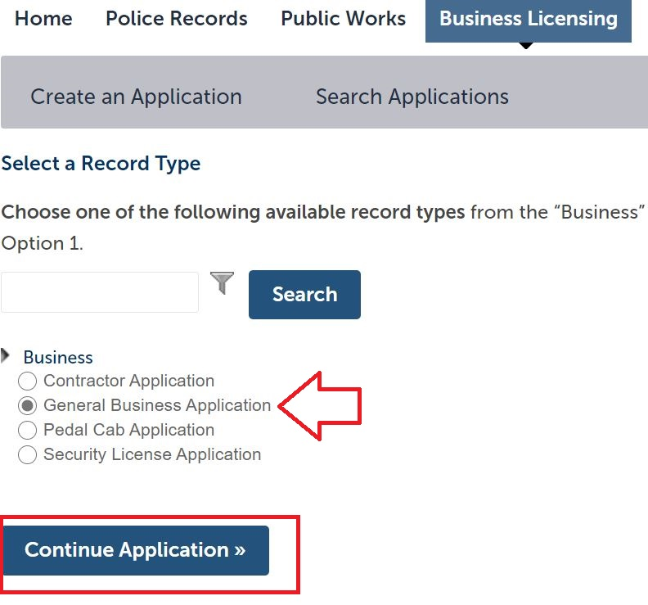

- In step 1 of the application flow, enter the company’s business trade name in the Business Name/Applicant Name field if applying for a company license. If applying for an individual license (such as funeral escort driver), enter your first and last name in this field.

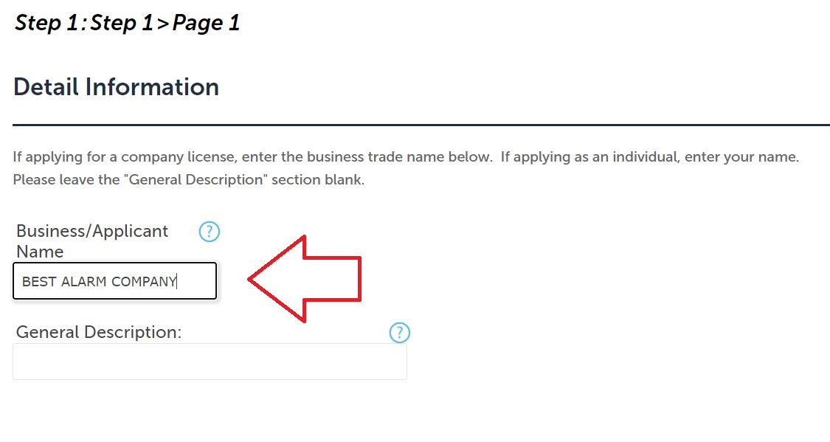

- If applying for a company license, add the company information as a contact in the next step under the Applicant option. If applying for an individual license, enter your personal information under the Applicant option.
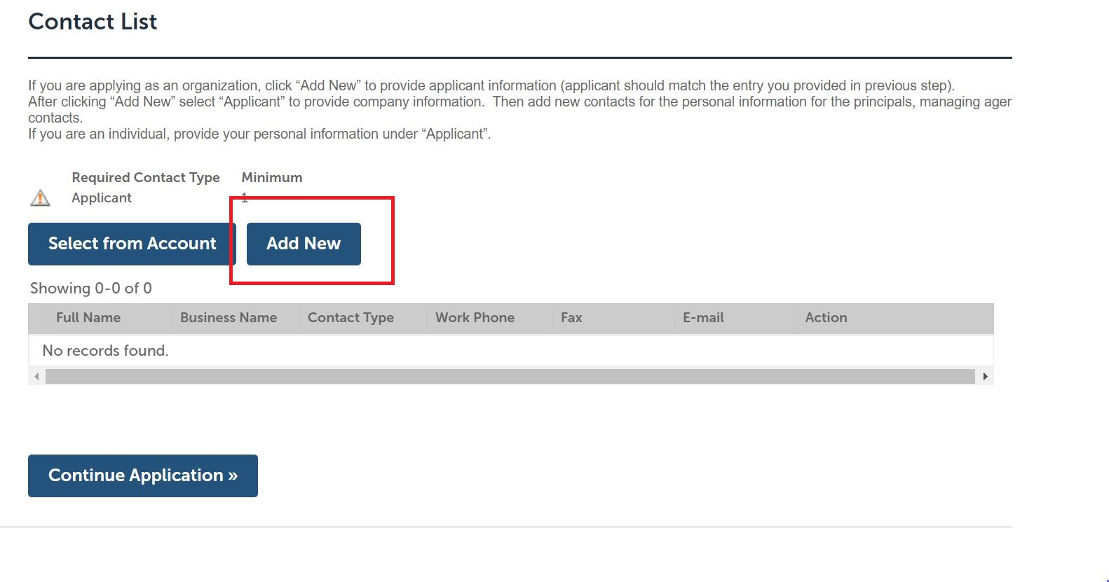

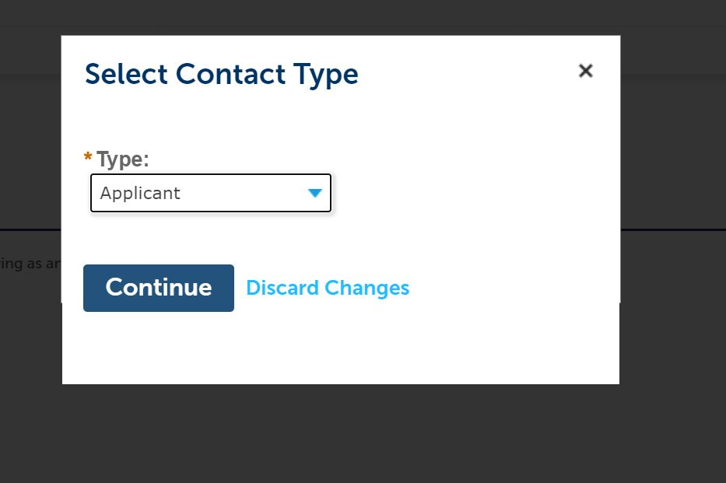

- If applying for a company license, add all additional relevant principals, managing agents, and the registered agent for service in the same fashion, ensuring personal (as opposed to business) information is provided for all individuals. If the personal details for any of the individuals listed here is on file from when you registered the account, you may import their data here by clicking the Select from Account option. NOTE: A resident agent for service located in the State of Colorado is required for ALL company licenses.

If applying for an individual license, additional contacts are unnecessary; simply move forward in the application.
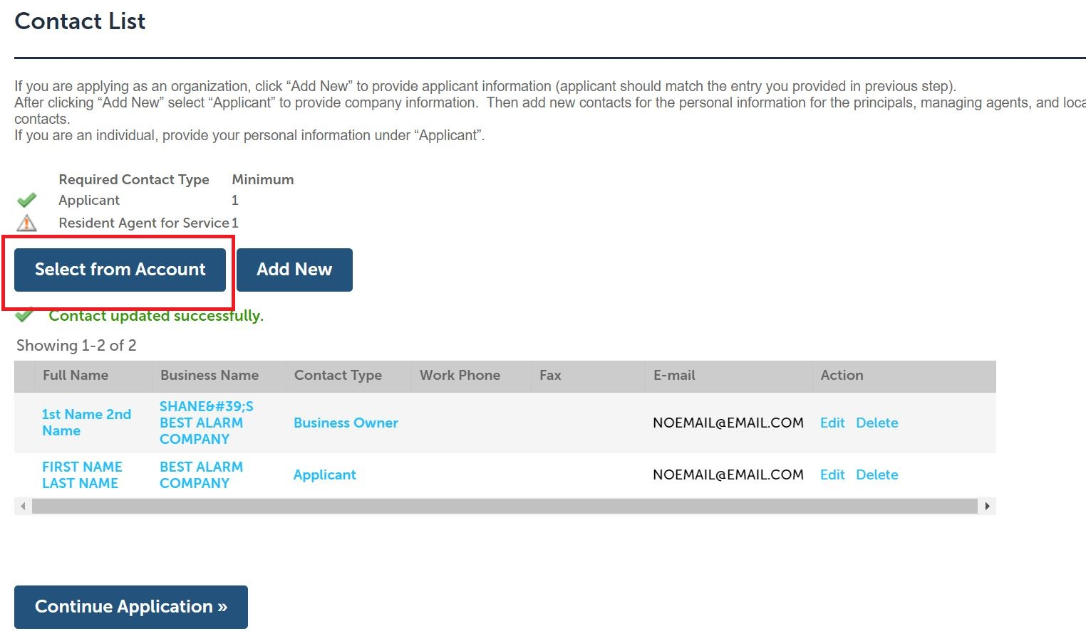

- Choose the license type for which you are applying from the Type of License drop-down menu, and answer the resulting questions in the Custom Fields step of the application flow.
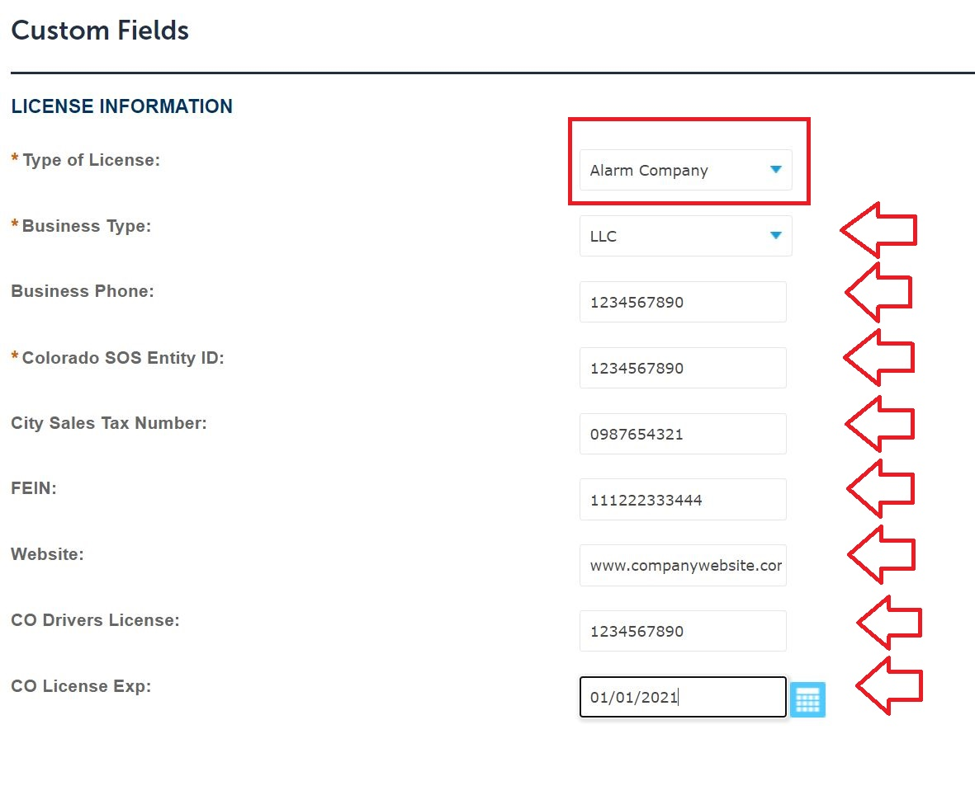

- If applying for a company license, enter the details of all required insurance policies in the Insurance fields of the Custom Lists workflow. Ensure an entry is provided for each policy. If your company is not required to carry workers’ compensation by State law, or if you desire to waive required automobile insurance on the grounds of not using commercial vehicles, type WAIVED in the respective policy number fields and enter the policy expiration dates as 01/01/2001. NOTE: An insurance waiver document is required for any policies you wish to waive. Please contact the City Clerk’s Office to obtain the insurance waiver form.
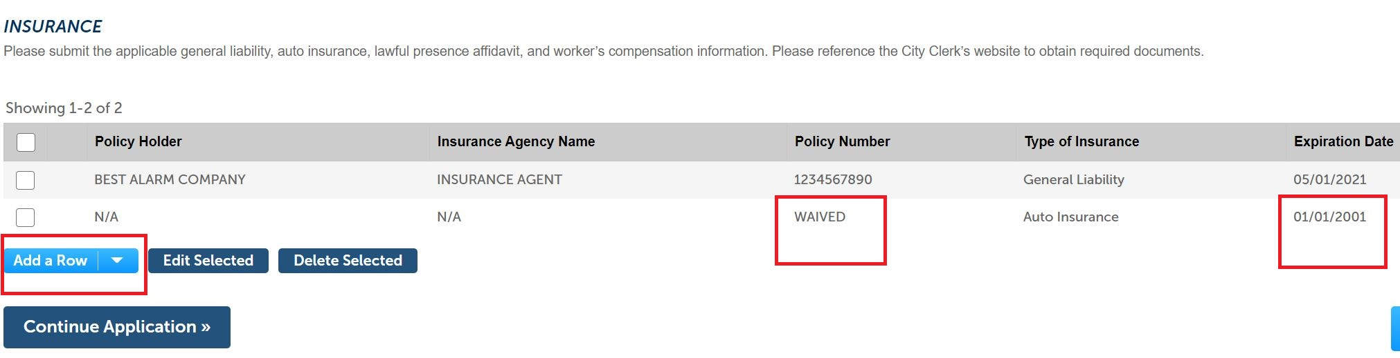

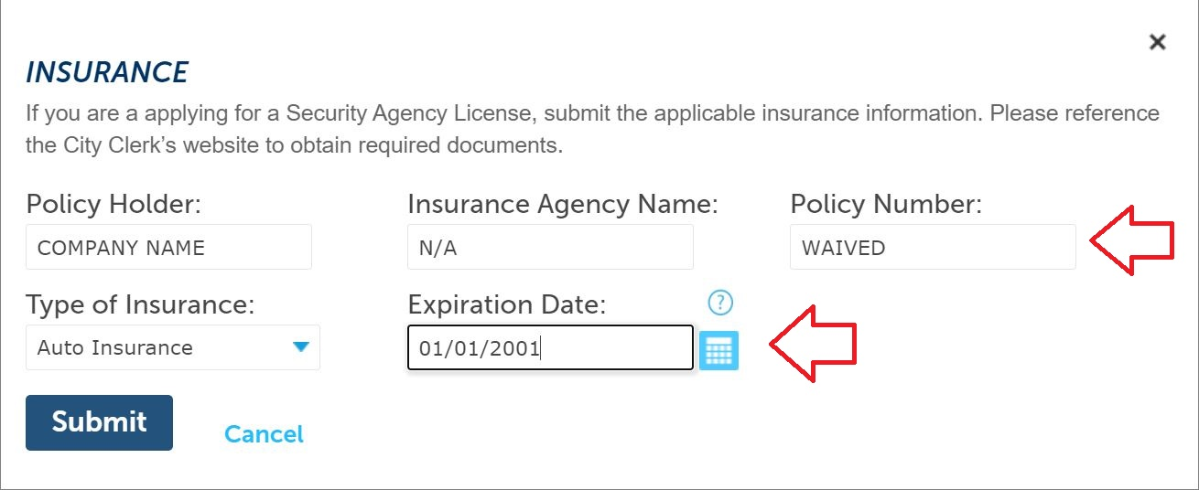

- If applying for a Pawnbroker License, enter the physical address of the pawnshop premises. If applying for any other license type, skip this step.
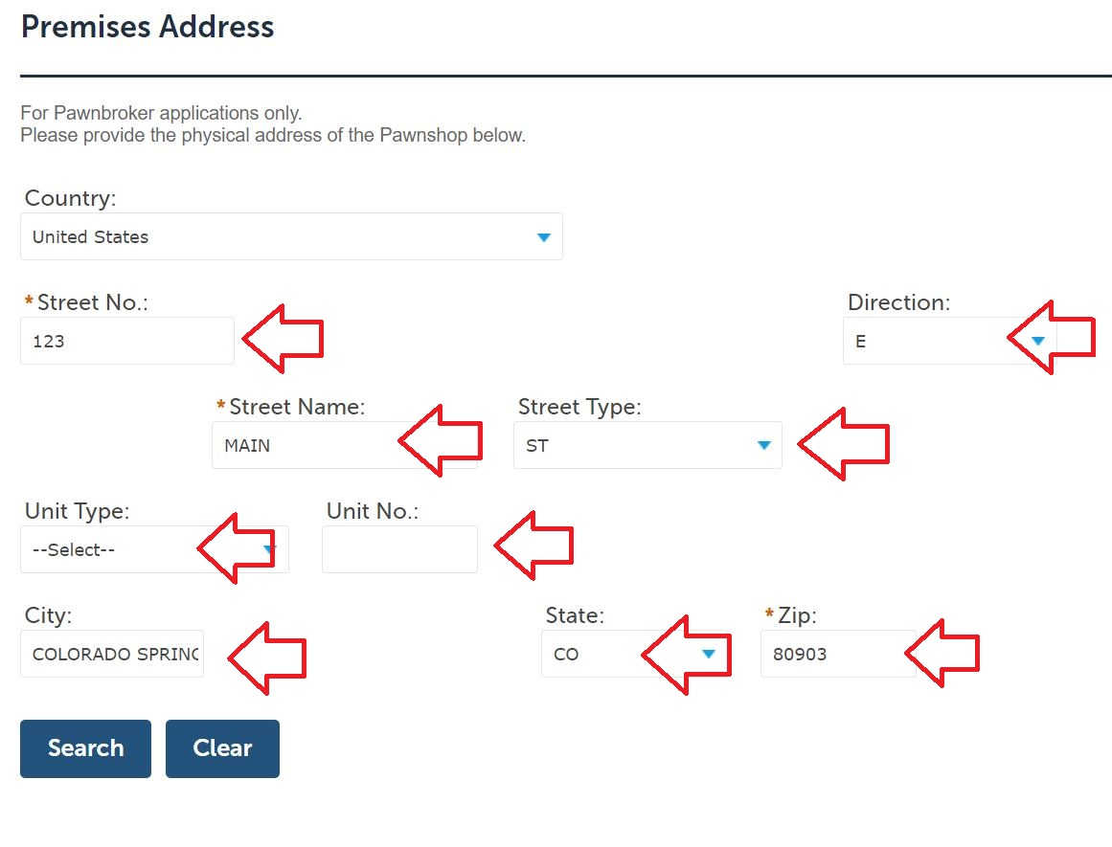

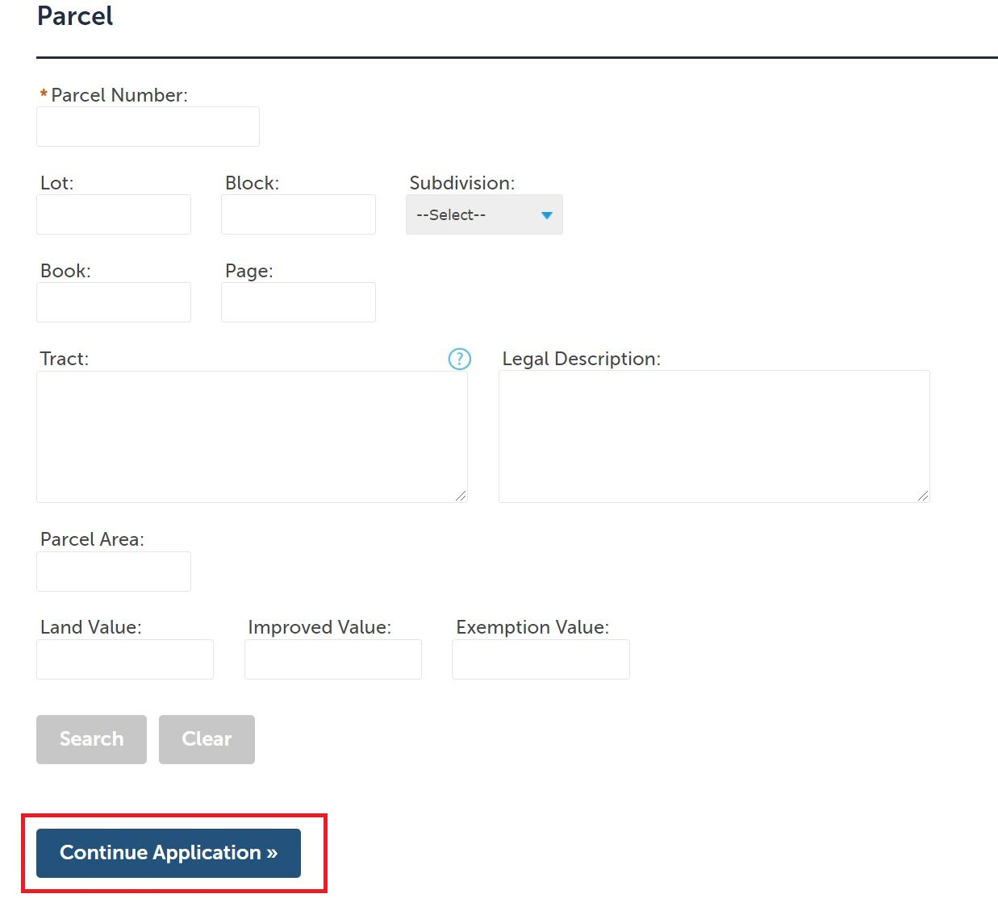
- Skip the step labelled Parcel and simply click Continue Application.

- In the next step, click Add to attach all required documentation. This will typically include the Secretary of State Trade Name Registration and/or Certificate of Good Standing, insurance Acord documents, bonds, insurance waivers, and the Department Review Form if applicable. Attachments are required. Once all necessary documents have been uploaded, click Continue Application to move forward to Step 3.
NOTE: All required documents must be uploaded for a license to be issued.
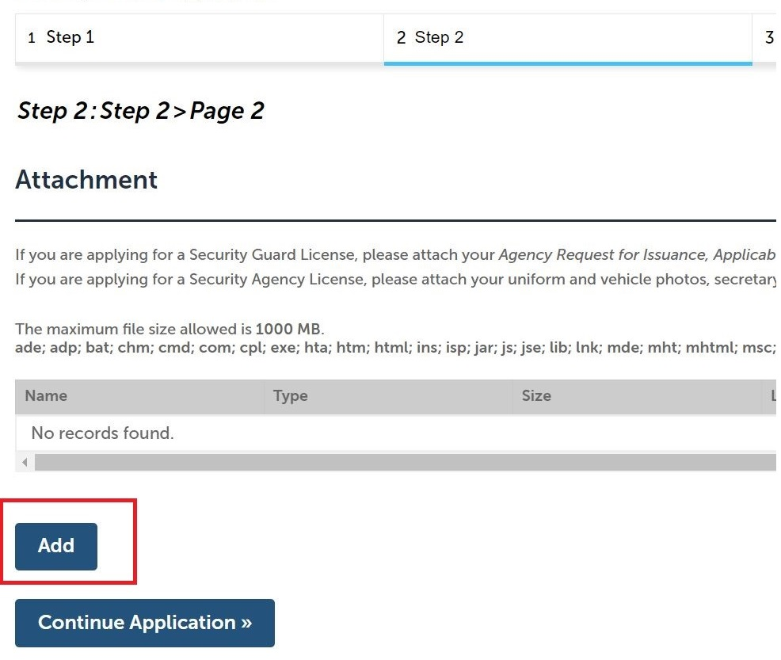

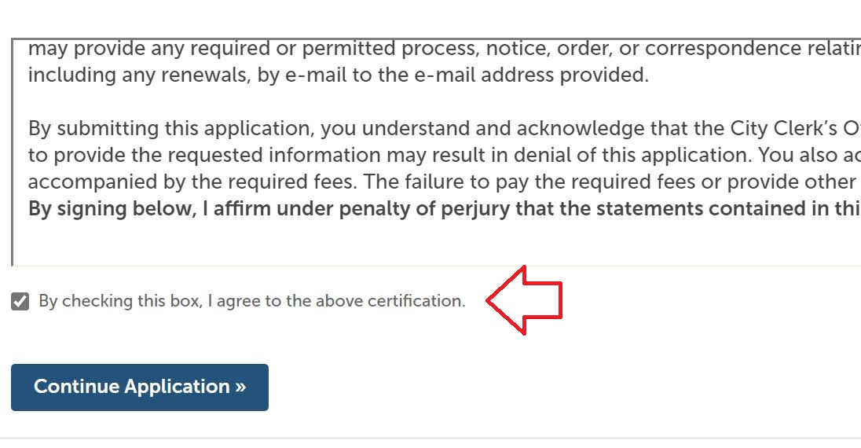
- In step 3 of the workflow, review all information for accuracy. At the bottom of the page, read the language in the certification window, and check the box below it to confirm you understand and agree. Then move forward by clicking Continue Application.

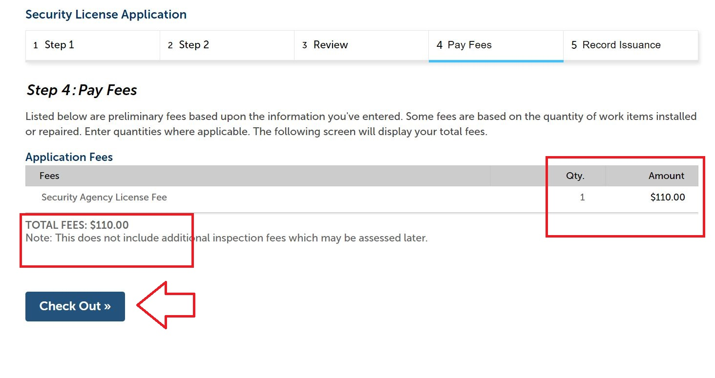
- In step 4 of the workflow, review the payment information for accuracy, and click Check Out. The next screen will review all items in your cart. Click Checkout again to move forward with paying the license fees.

- Submit payment details and click Submit Payment to finalize.
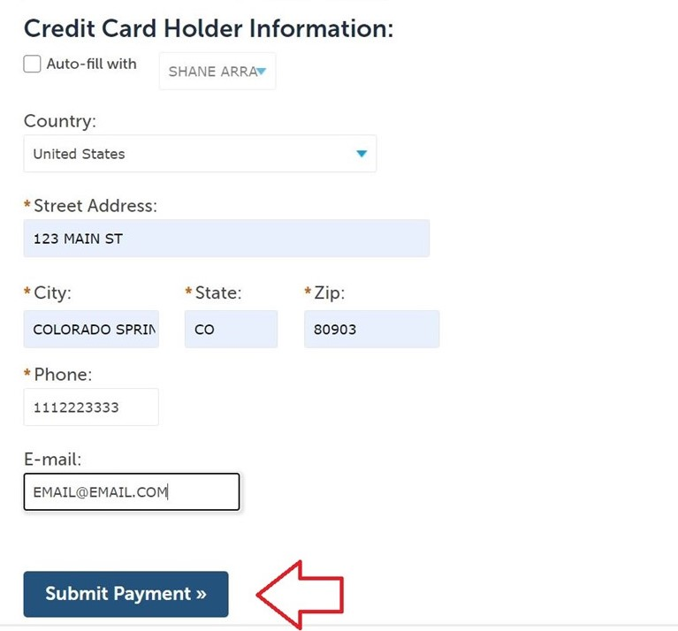

- Once you receive payment confirmation, the application has officially been forwarded to the City Clerk’s office for review. Please note, the license is not yet issued at this stage. If any additional information is required, City Clerk general business licensing staff will contact the e-mail address provided for the Applicant. Otherwise, the license will be issued by City Clerk staff, and it will be mailed to the address provided for the Applicant.
