ACA How-To: Renewal

- Register or log in.
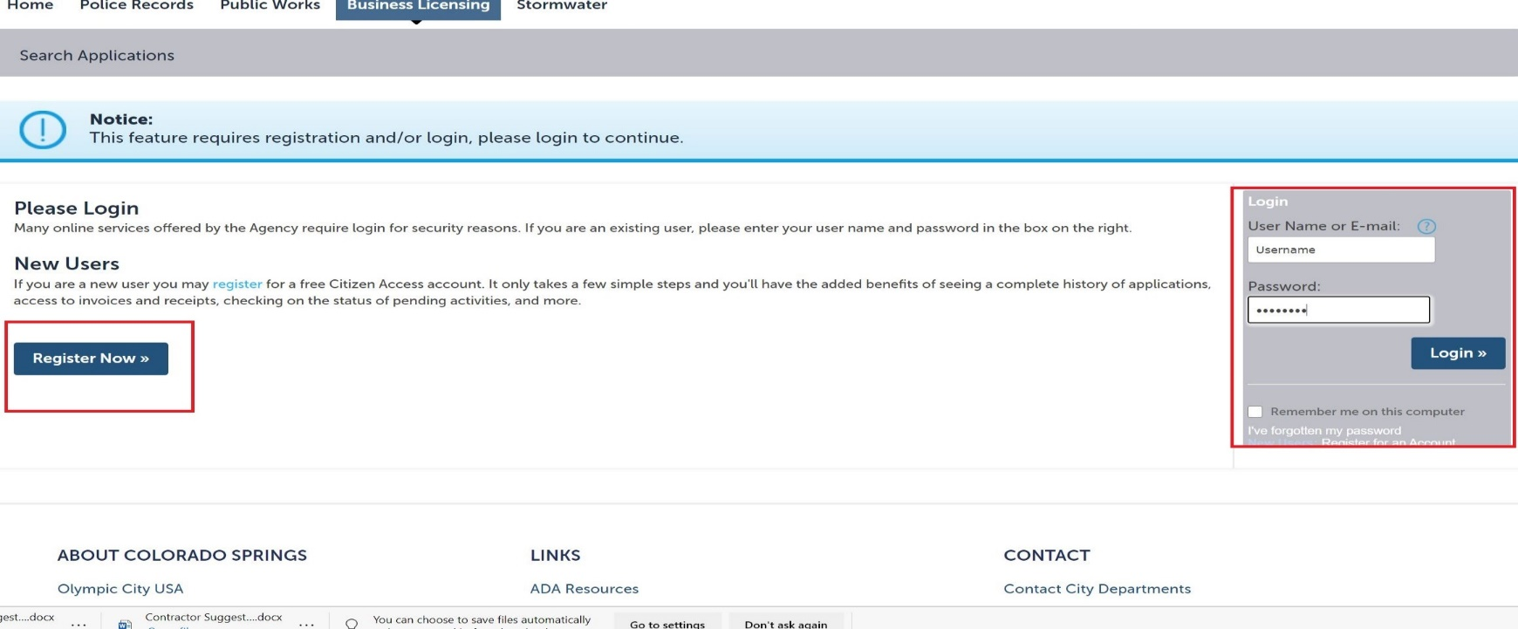

- Once you have created your account call the City Clerk’s office at 719-385-5901, Option 1 to link your new Accela account to your old account. Do not move forward until this step is complete.

- Under the Home tab, select My Records.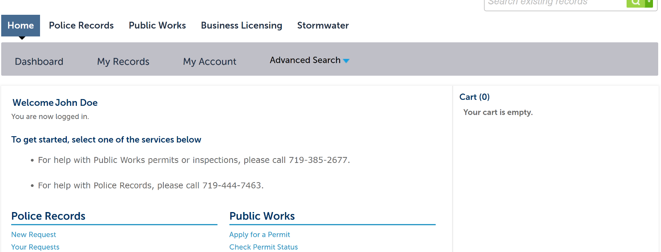
- Select Business Licensing
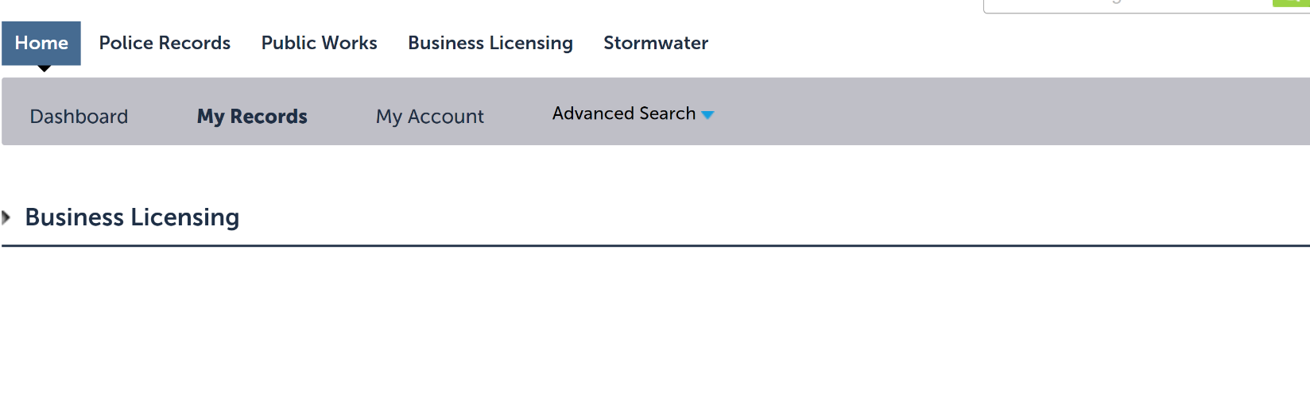
- Select the Record Number

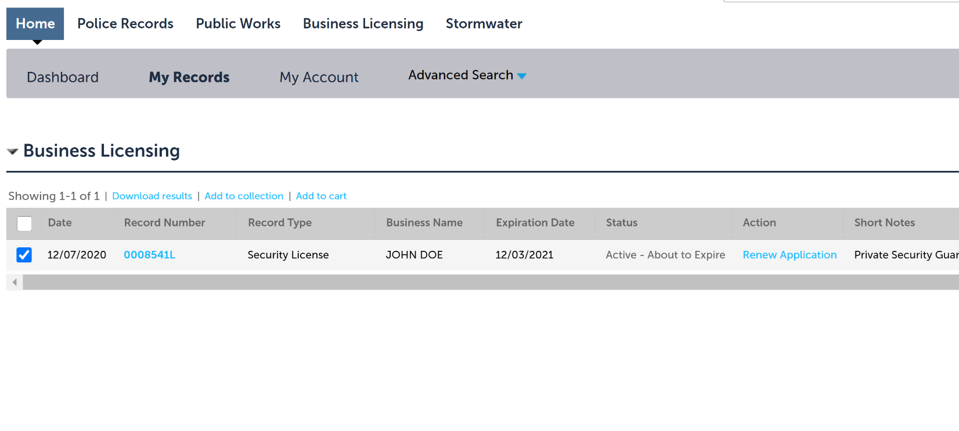
- Select Renew Application
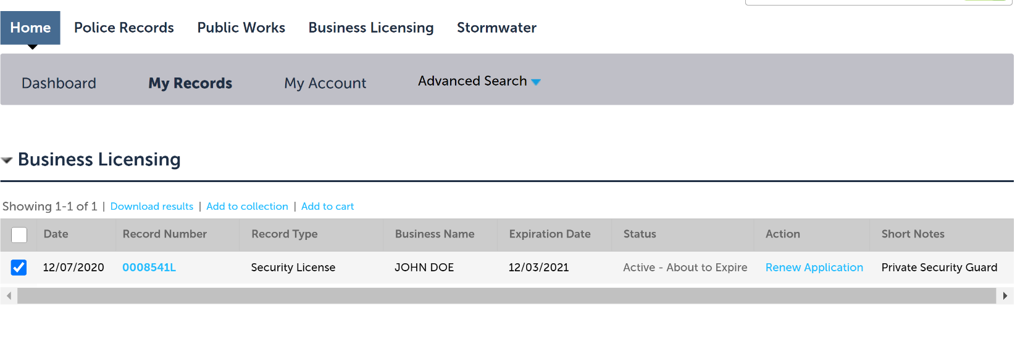

- Check to make sure information is correct from the previous year. If there are changes, use steps below to update.
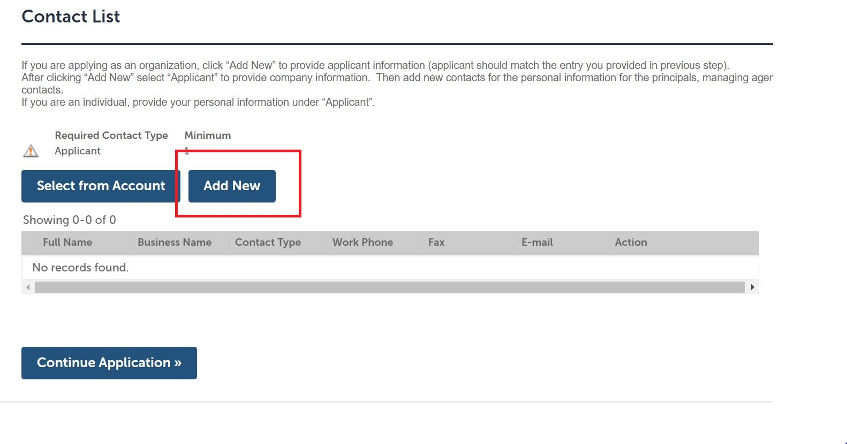

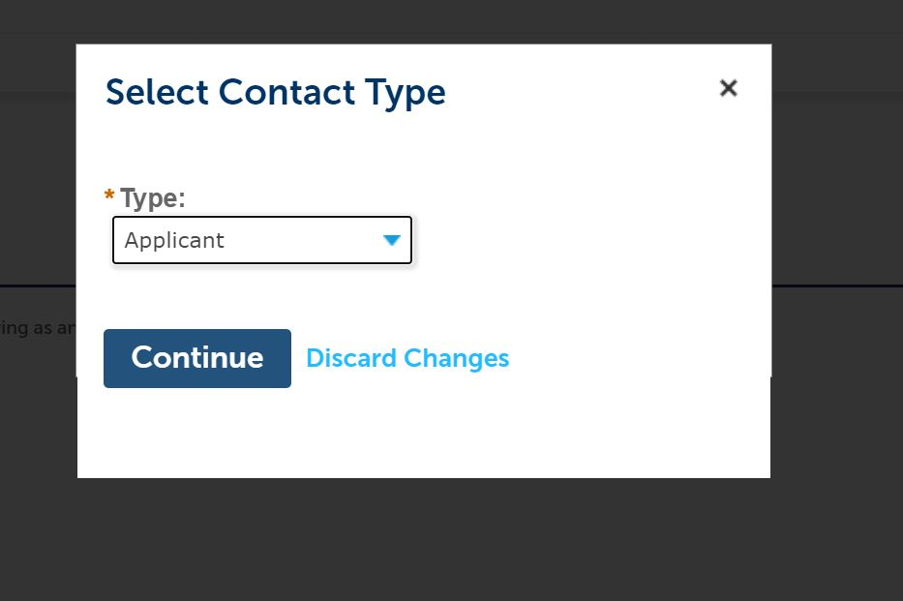

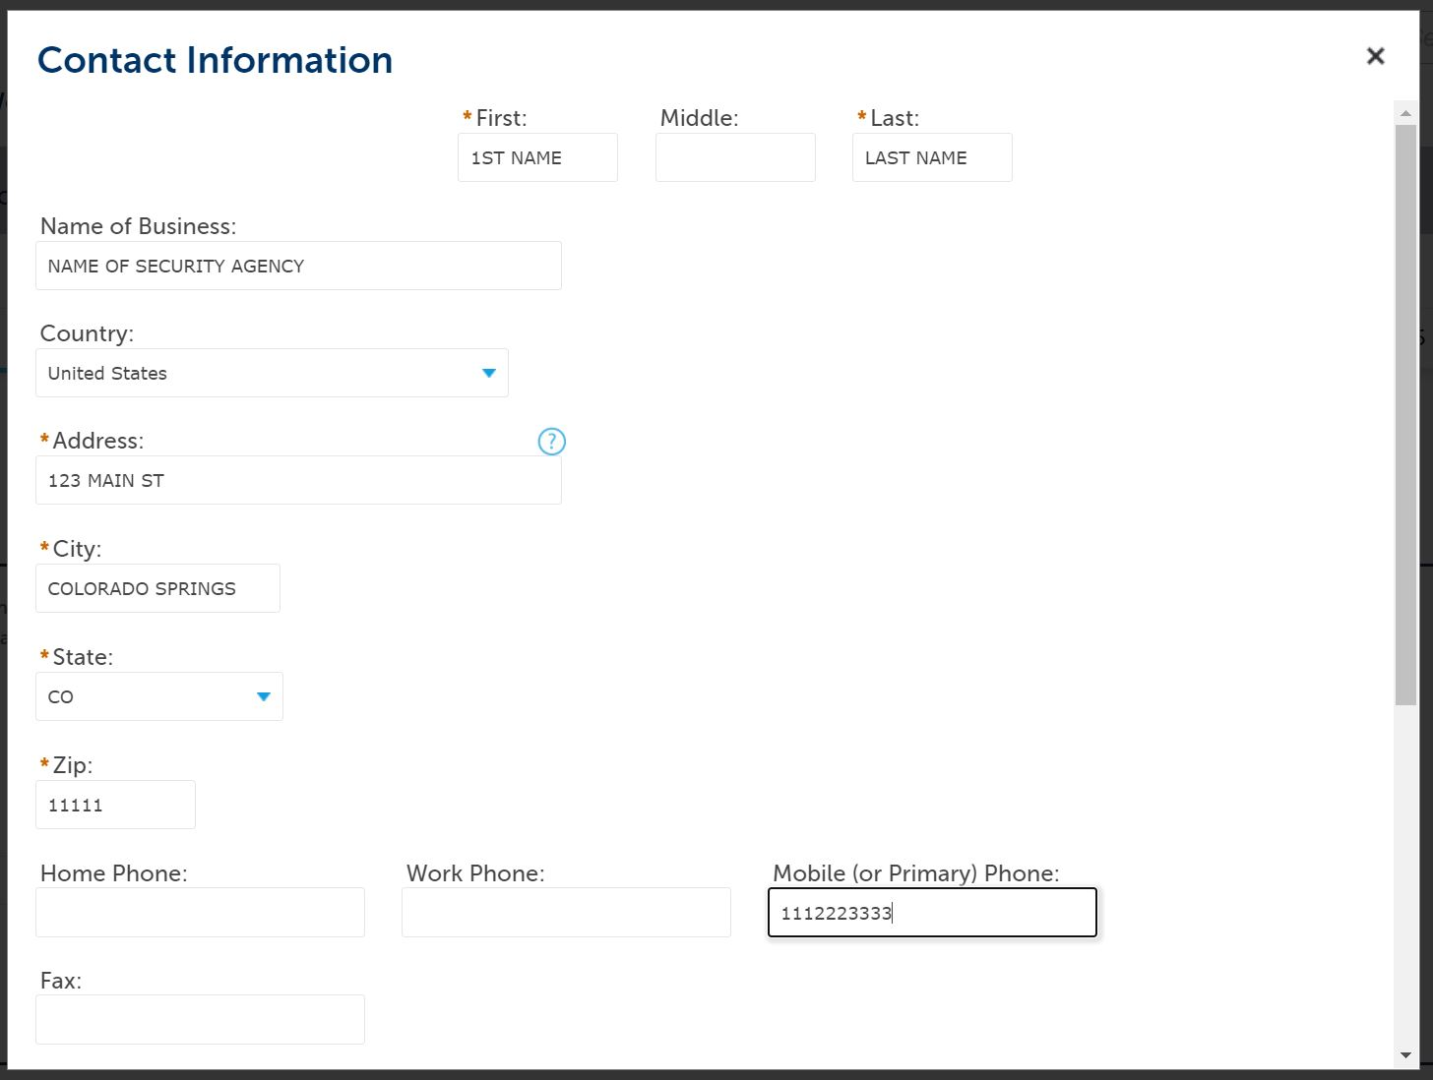

- Check to make sure information is correct from the previous year. If there are changes, use steps below to update.
If applying for a Security Agency License, add all additional relevant principals, managing agents, and the registered agent for service in the same fashion, ensuring personal (as opposed to business) information is provided for all individuals. If the personal details for any of the individuals listed here is on file from when you registered the account, you may import their data here by clicking the Select from Account option.

If applying for a Private Security Guard License, additional contacts are unnecessary; simply move forward in the application.
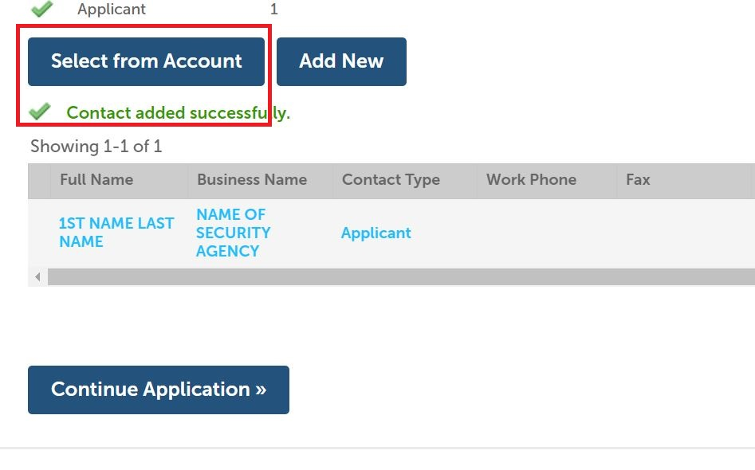

- Check to make sure information is correct from the previous year. If there are changes, use steps below to update.
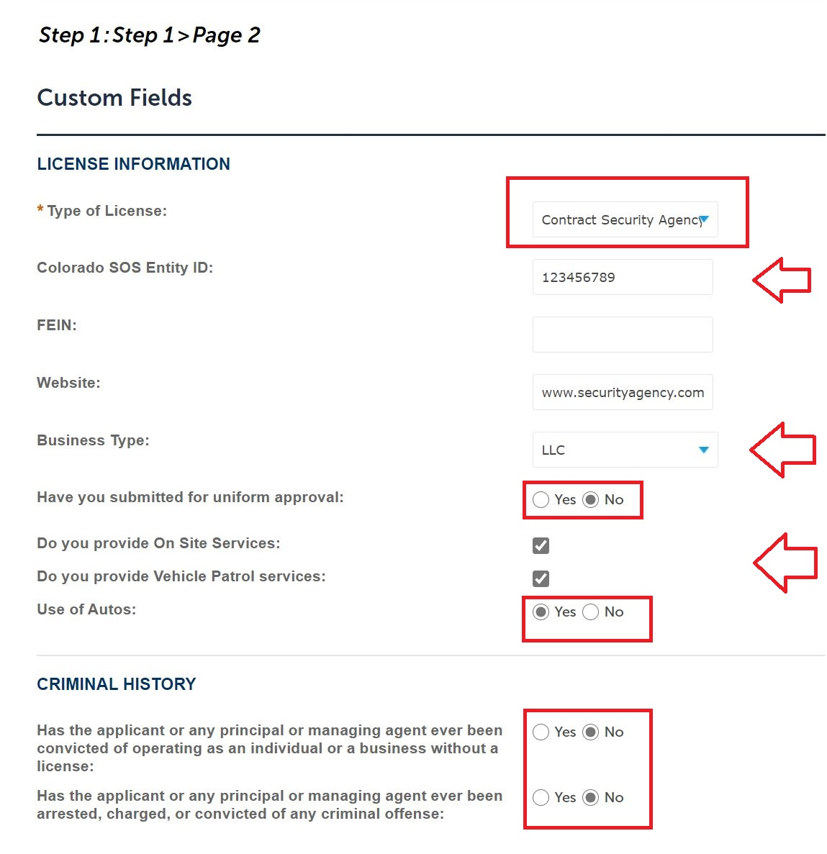
Select which license type for which you are applying from the Type of License drop-down menu, and answer the questions in the Custom Fields step of the application flow. Note, the system generates different questions depending upon which license type you seek. For Contract Security Agency Licenses, the Secretary of State number must be provided.

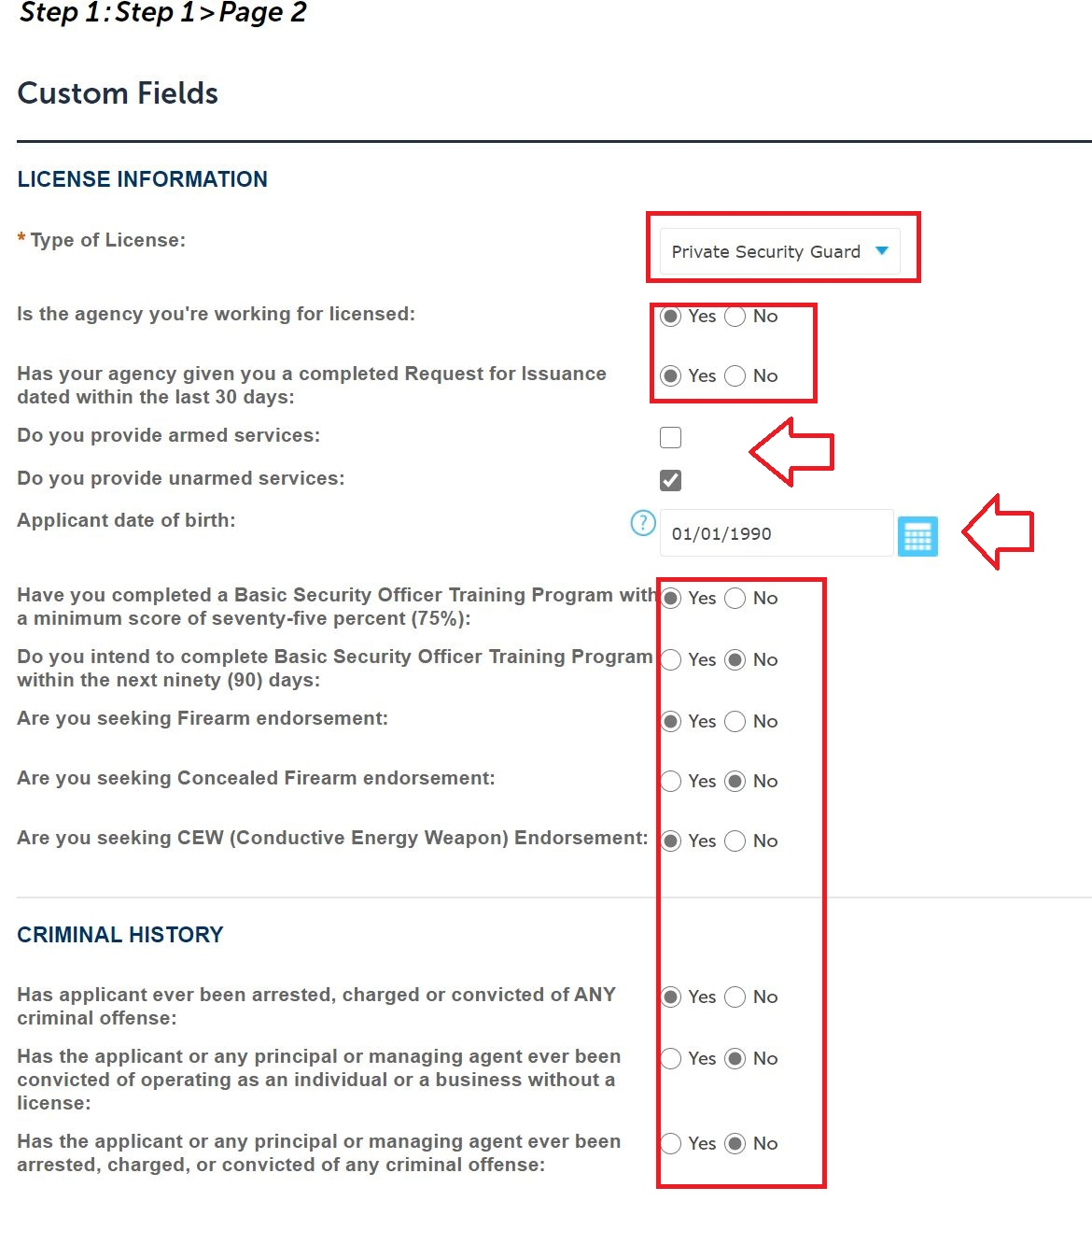

- Check to make sure information is correct from the previous year. If there are changes, use steps below to update.
In the Custom Lists flow of the application, Private Security Guard License applicants must enter the license number for his or her employing contract security agency. Contract Security Agency applicants may skip this step.

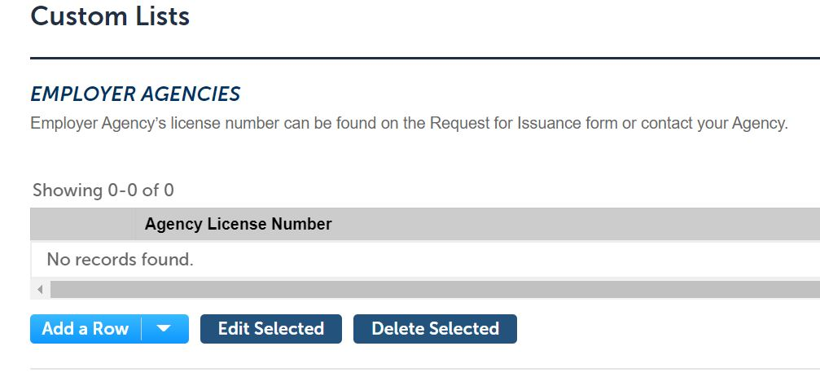
- Check to make sure information is correct from the previous year. If there are changes, use steps below to update.
In the following Custom Lists fields, provide the previous 5 years residence and work history. If applicable, also provide criminal history details, regardless of disposition or length of time that has passed since the charges, arrests, or convictions occurred.
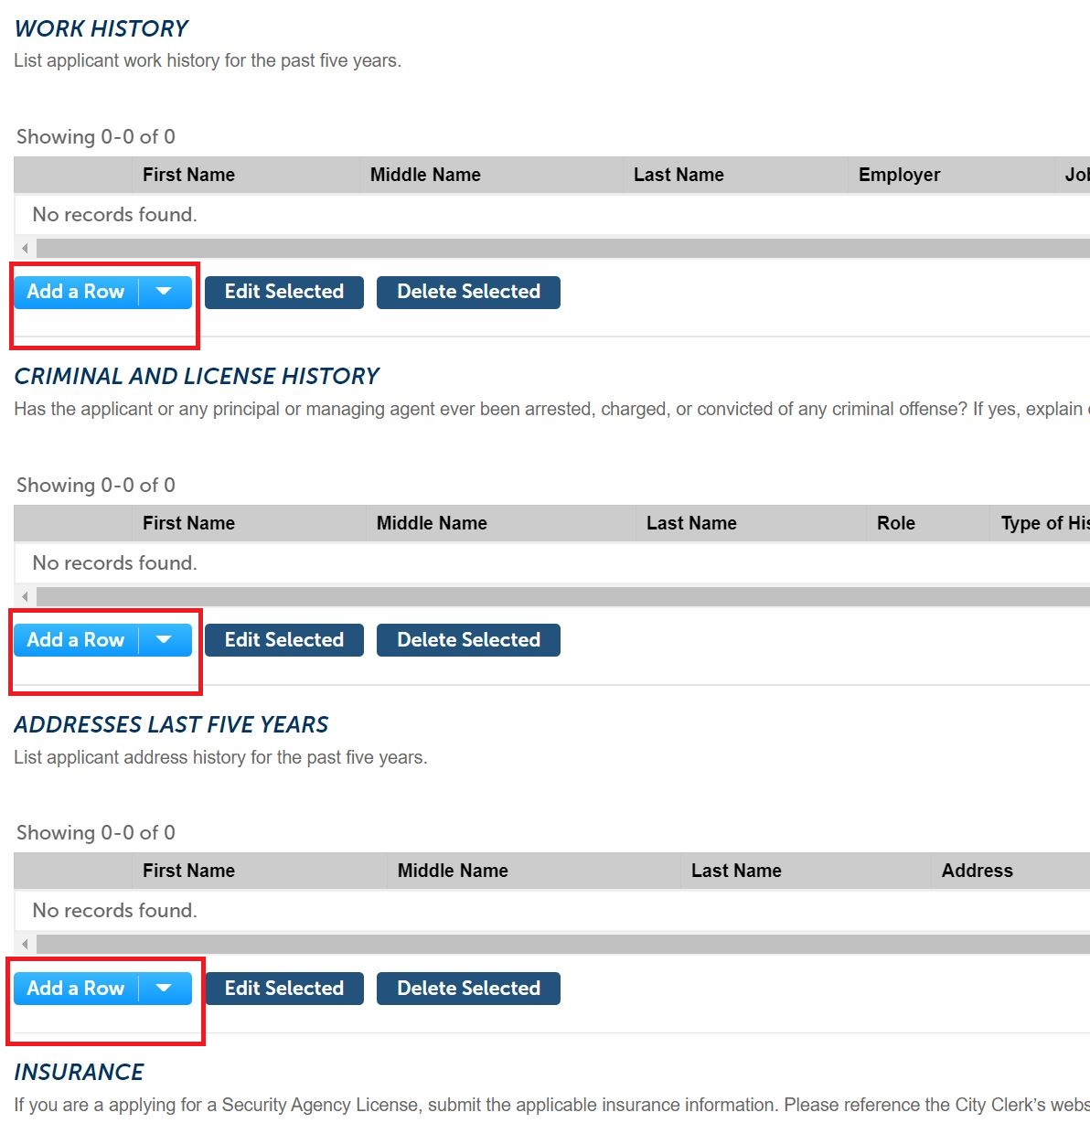

- Check to make sure information is correct from the previous year. If there are changes, use steps below to update.
If applying for a Contract Security Agency License, enter the details of the automobile, general liability, and workers’ compensation policies in the Insurance fields of the Custom Lists workflow. Ensure an entry is provided for each policy. If your agency is not required to carry workers’ compensation by State law, or you are not using vehicles and therefore do not require automobile insurance, type WAIVED in the policy number fields and enter the policy expiration date as 01/01/2001.

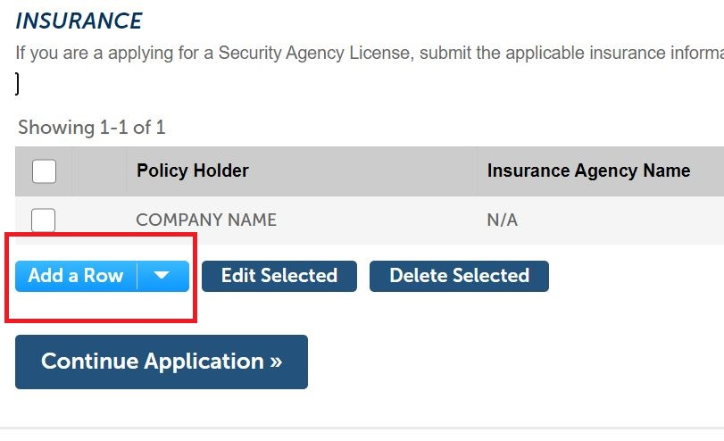

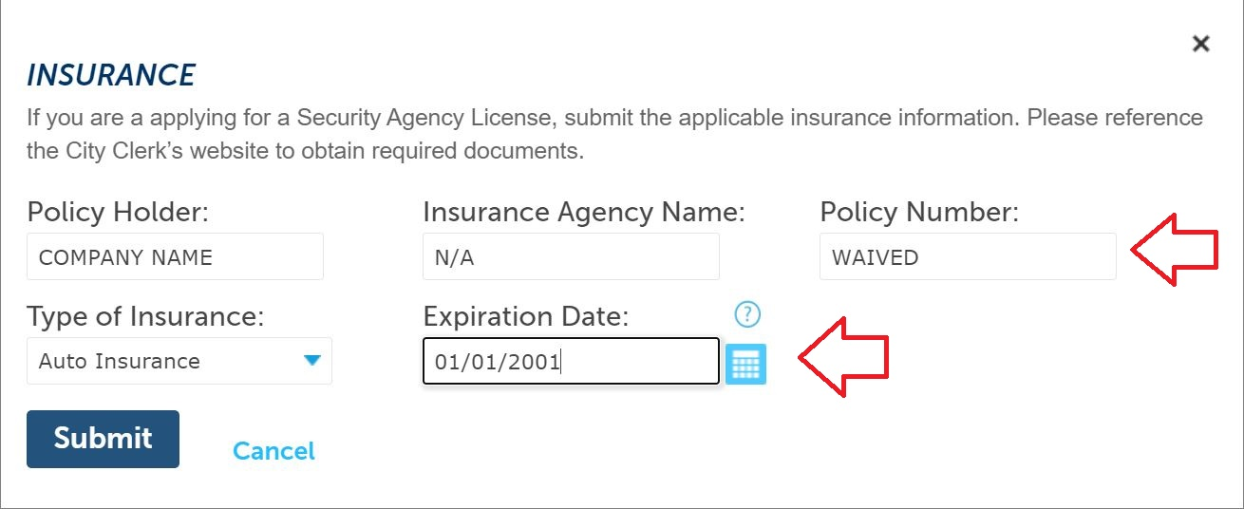

- In step 2 of the workflow, click Add to attach all required documentation. For Security Agency Licenses, attach the color photographs of the front and back of the uniforms, ensuring all badges and patches are legible and compliant with City Code; the color photographs of both sides of the security vehicles, ensuring the verbiage is compliant; the Secretary of State Trade Name Registration and/or Certificate of Good Standing; the insurance Acord documents; and any other required documentation.

For Private Security Guard Licenses, attach the Request for Issuance, ensuring it is dated within the last 30 days and was completed in its entirety by an authorized manager for the employing security agency; all applicable training certificates; the Lawful Presence Affidavit, ensuring only ONE option was checked on the form; and any other required documentation.

Attachments are required. Once all necessary documents have been uploaded, click Continue Application to move forward to Step 3.

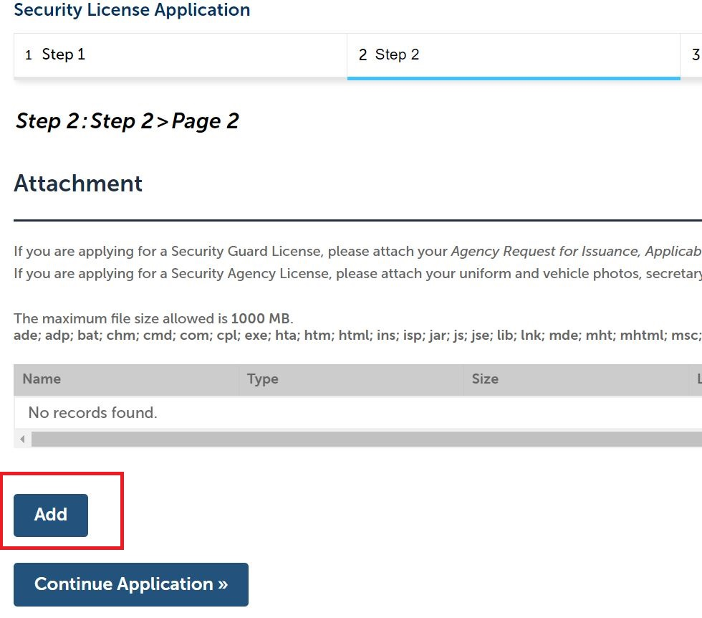

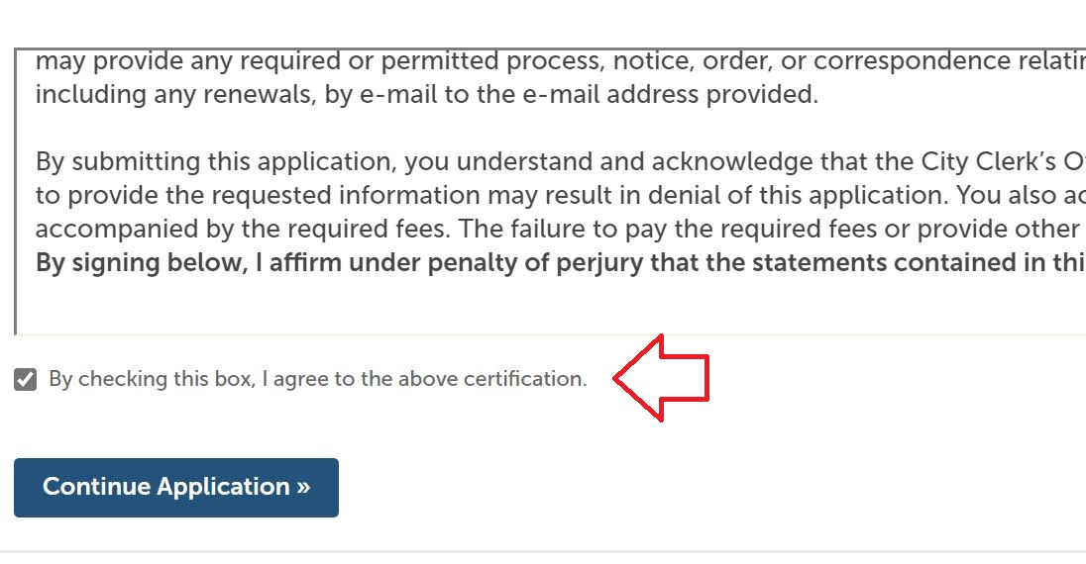
- In step 3 of the workflow, review all information for accuracy. At the bottom of the page, read the language in the certification window, and check the box below it to confirm you understand and agree. Then move forward by clicking Continue Application.

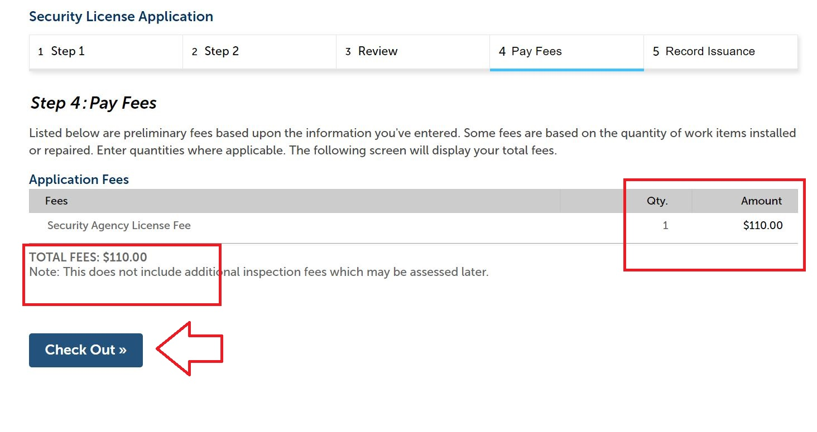
- In step 4 of the workflow, review the payment information for accuracy, and click Check Out. The next screen will review all items in your cart. Click Checkout again to move forward with paying the license fees.

- Submit payment details and click Submit Payment to finalize.