ACA Online Appication How-To: Security

- Register or log in.
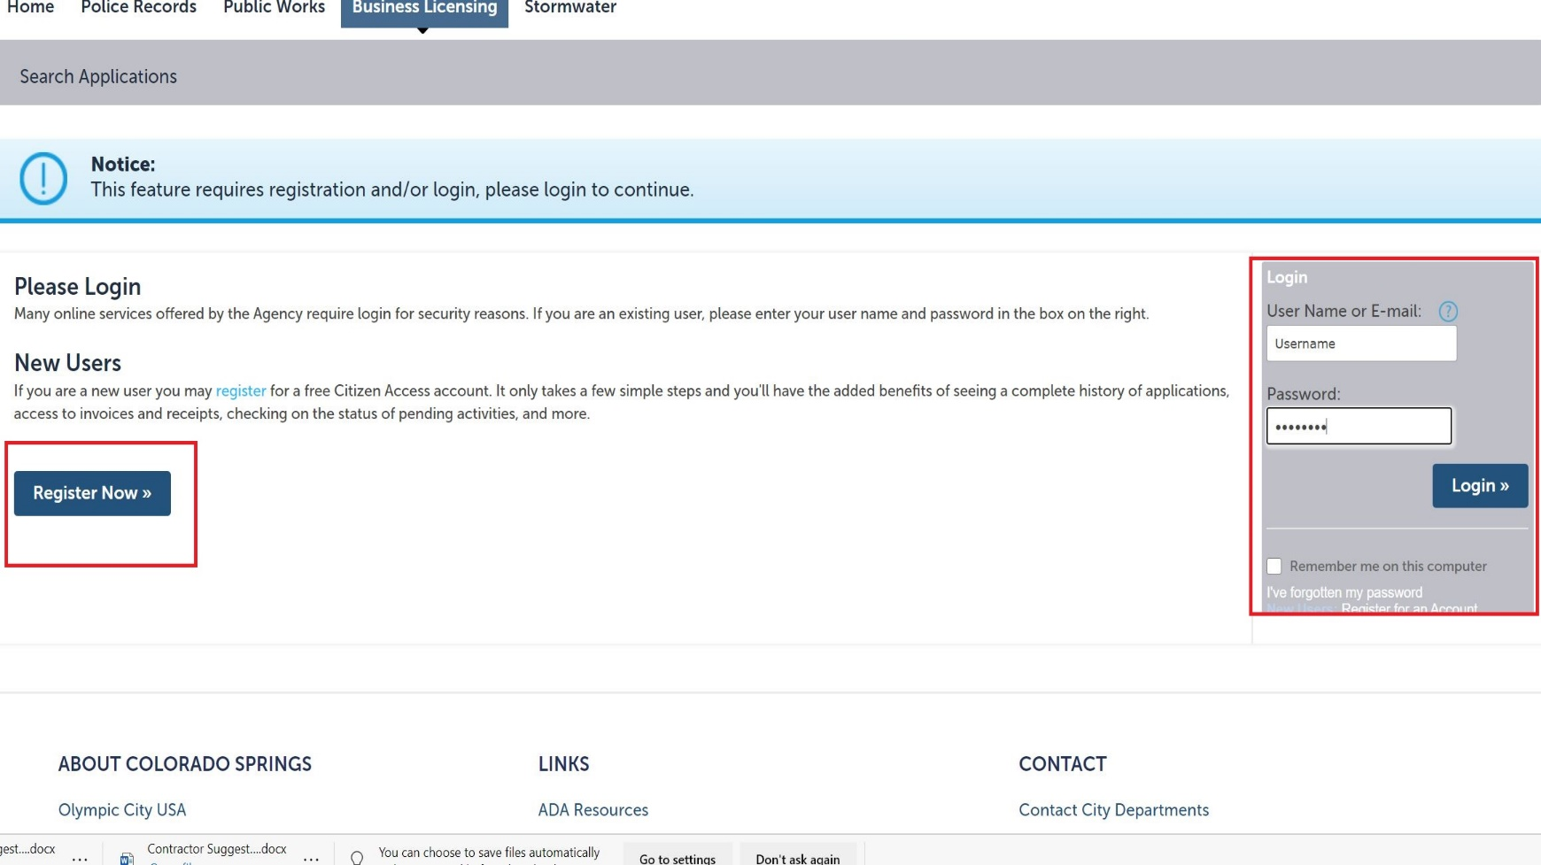

- Under the Business Licensing tab, agree to the terms and conditions prompt and click Continue Application.
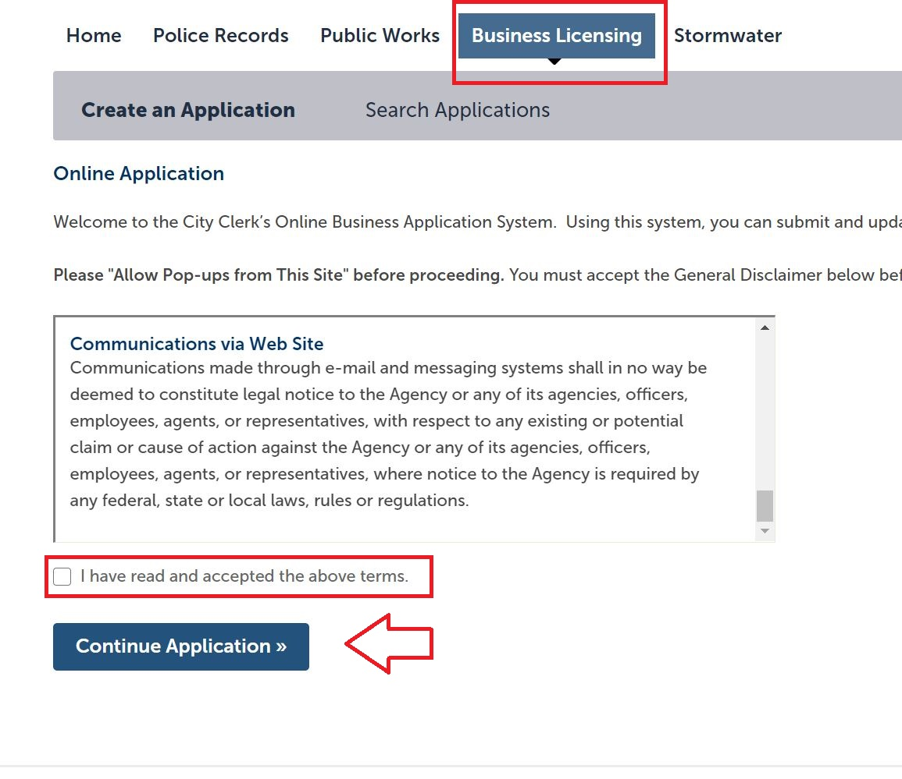

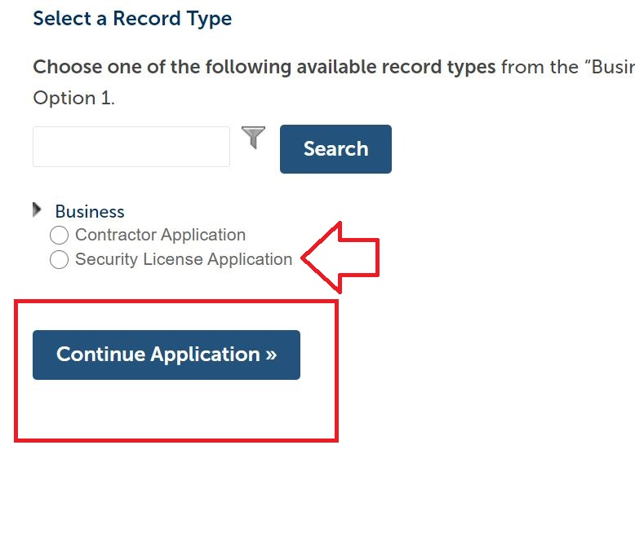
- Choose Security License Application and click Continue Application.

- In step 1 of the application flow, enter the security agency’s business trade name in the Business Name/Applicant Name field if applying for a Contract Security Agency License. If applying for a Private Security Guard License, enter the officer’s first and last name in this field.
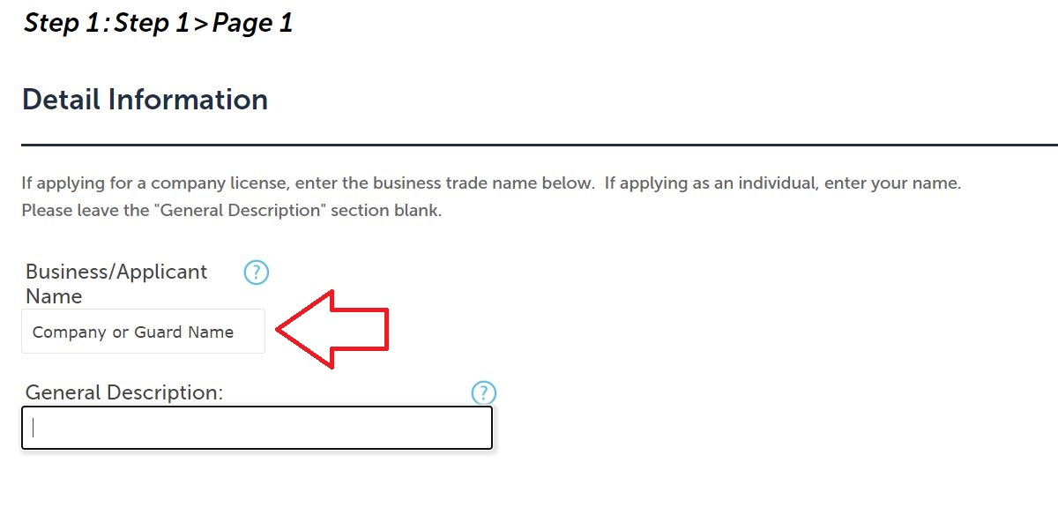

- If applying for a Security Agency License, add the company information as a contact in the next step under the Applicant option. If applying for a Private Security Guard License, enter the officer’s personal information under the Applicant option.
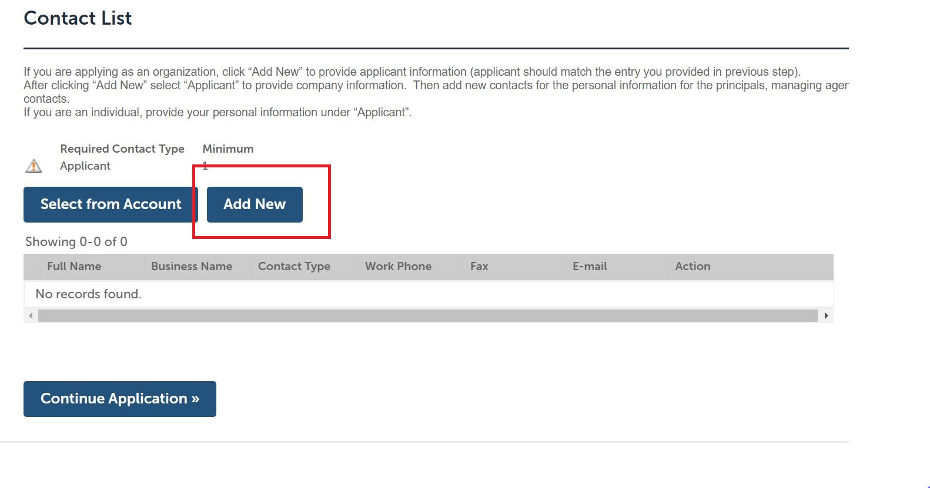

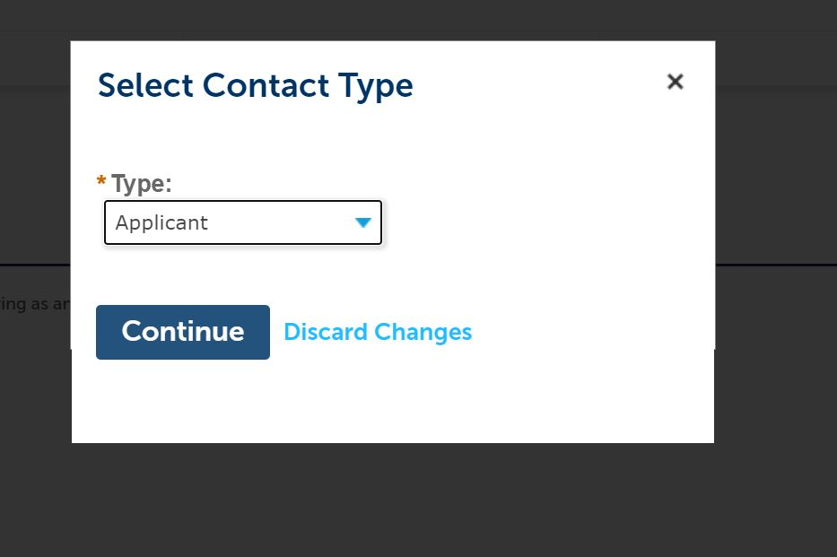

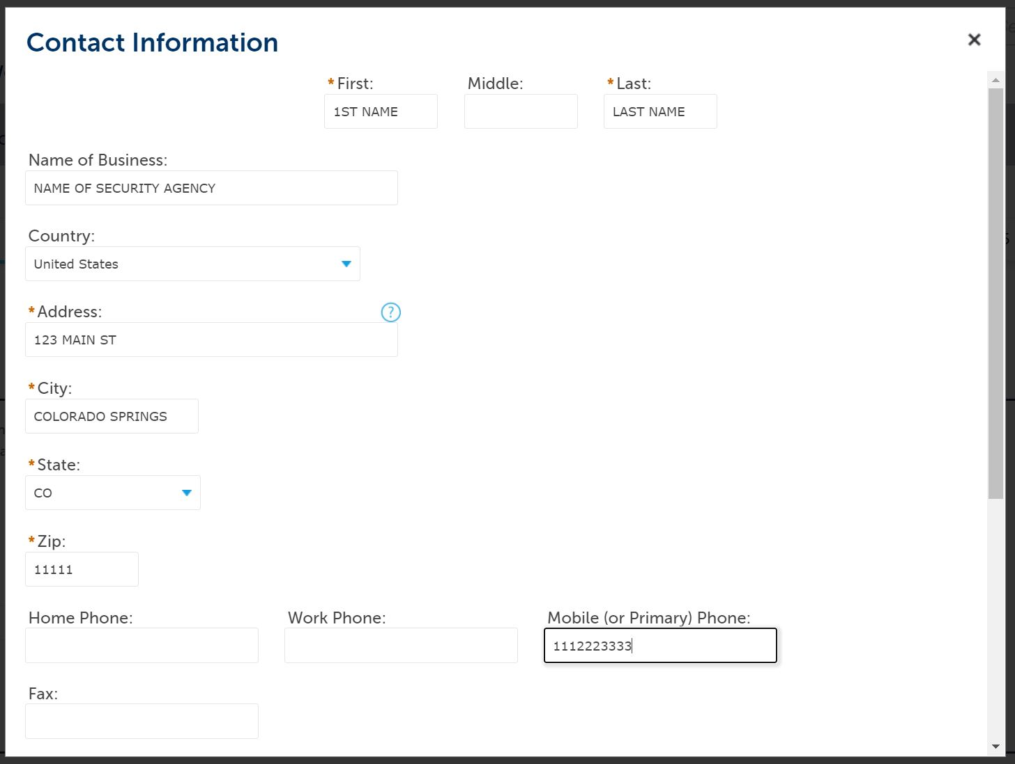

- If applying for a Security Agency License, add all additional relevant principals, managing agents, and the registered agent for service in the same fashion, ensuring personal (as opposed to business) information is provided for all individuals. If the personal details for any of the individuals listed here is on file from when you registered the account, you may import their data here by clicking the Select from Account option.

If applying for a Private Security Guard License, additional contacts are unnecessary; simply move forward in the application.
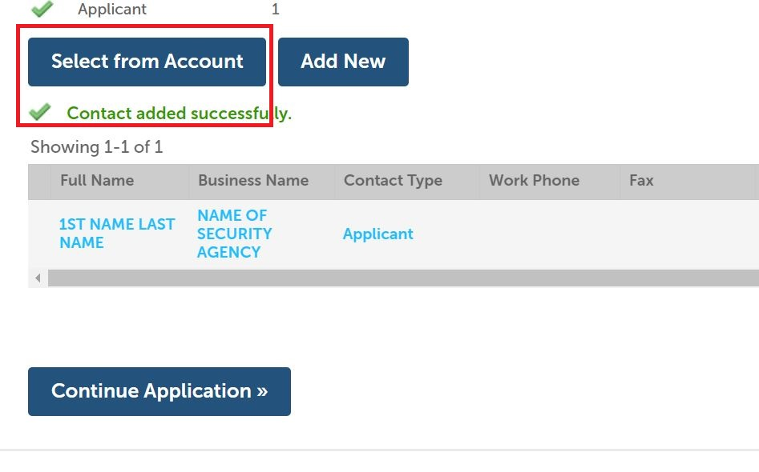

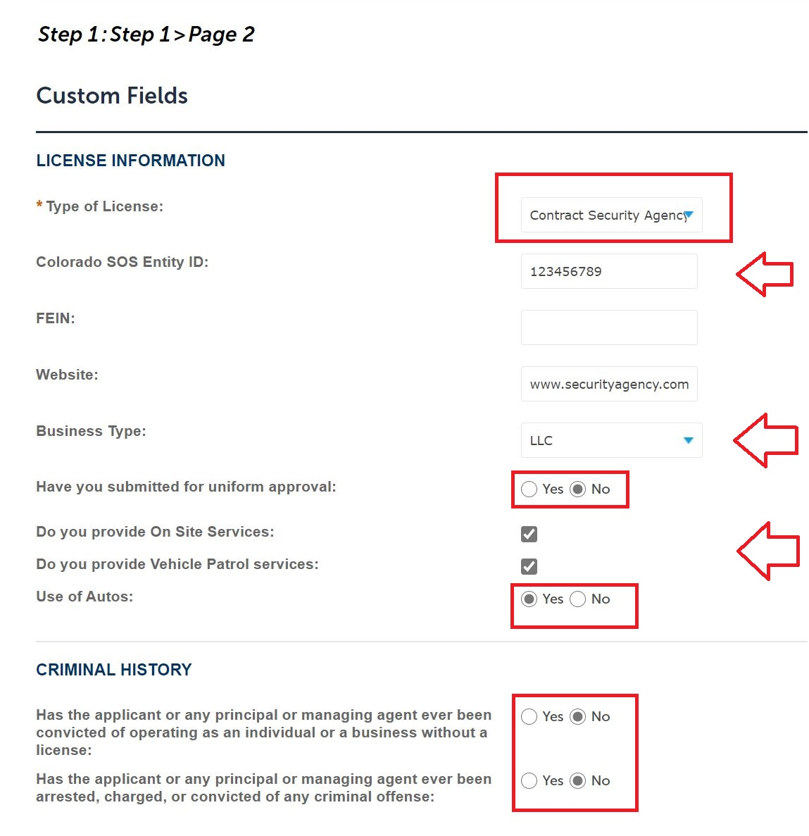
- Select which license type for which you are applying from the Type of License drop-down menu, and answer the questions in the Custom Fields step of the application flow. Note, the system generates different questions depending upon which license type you seek. For Contract Security Agency Licenses, the Secretary of State number must be provided.

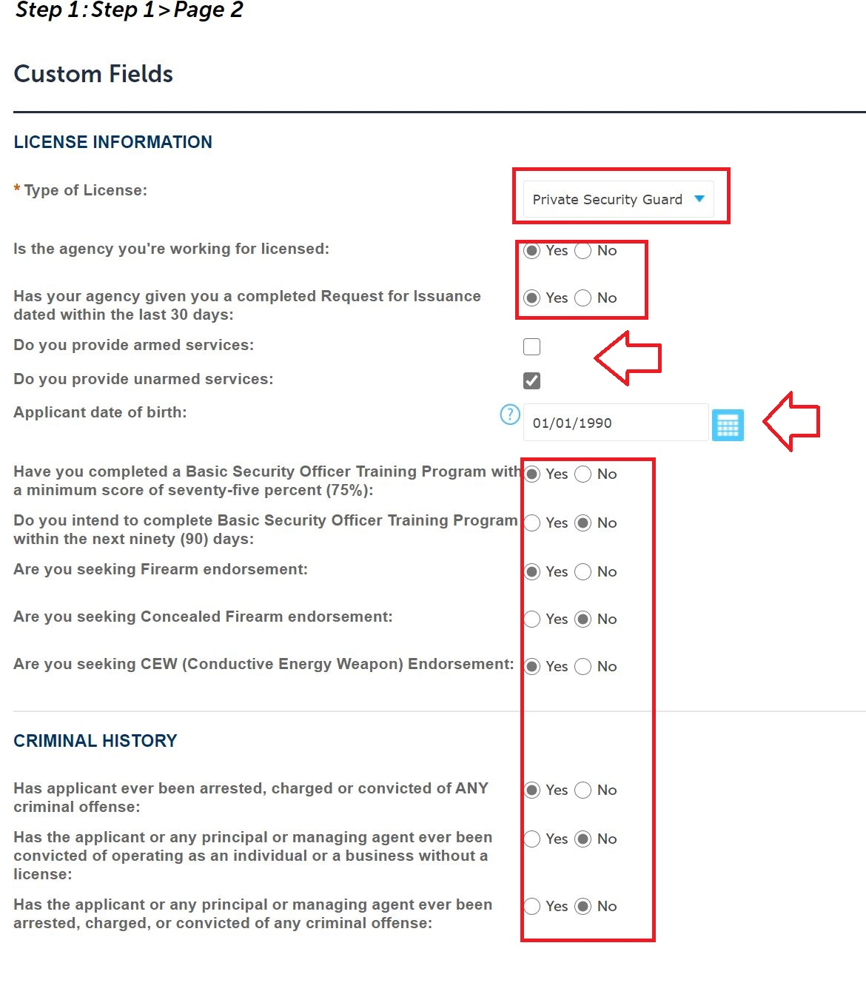

- In the Custom Lists flow of the application, Private Security Guard License applicants must enter the license number for his or her employing contract security agency. Contract Security Agency applicants may skip this step.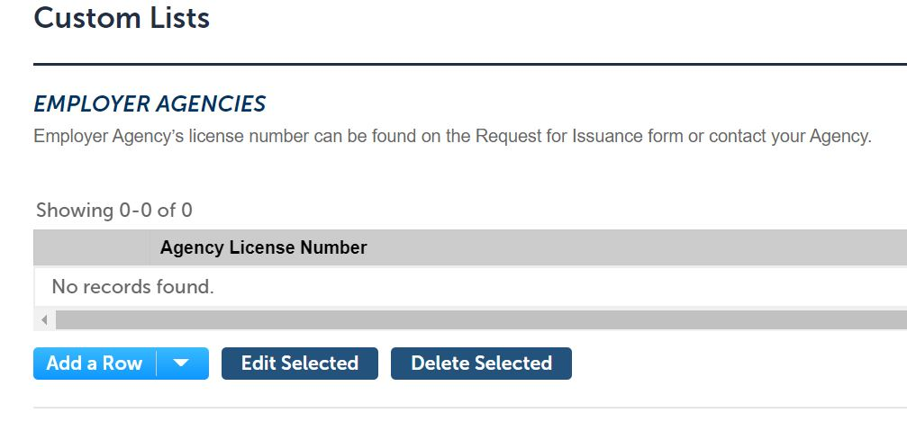
- In the following Custom Lists fields, provide the previous 5 years residence and work history. If applicable, also provide criminal history details, regardless of disposition or length of time that has passed since the charges, arrests, or convictions occurred.
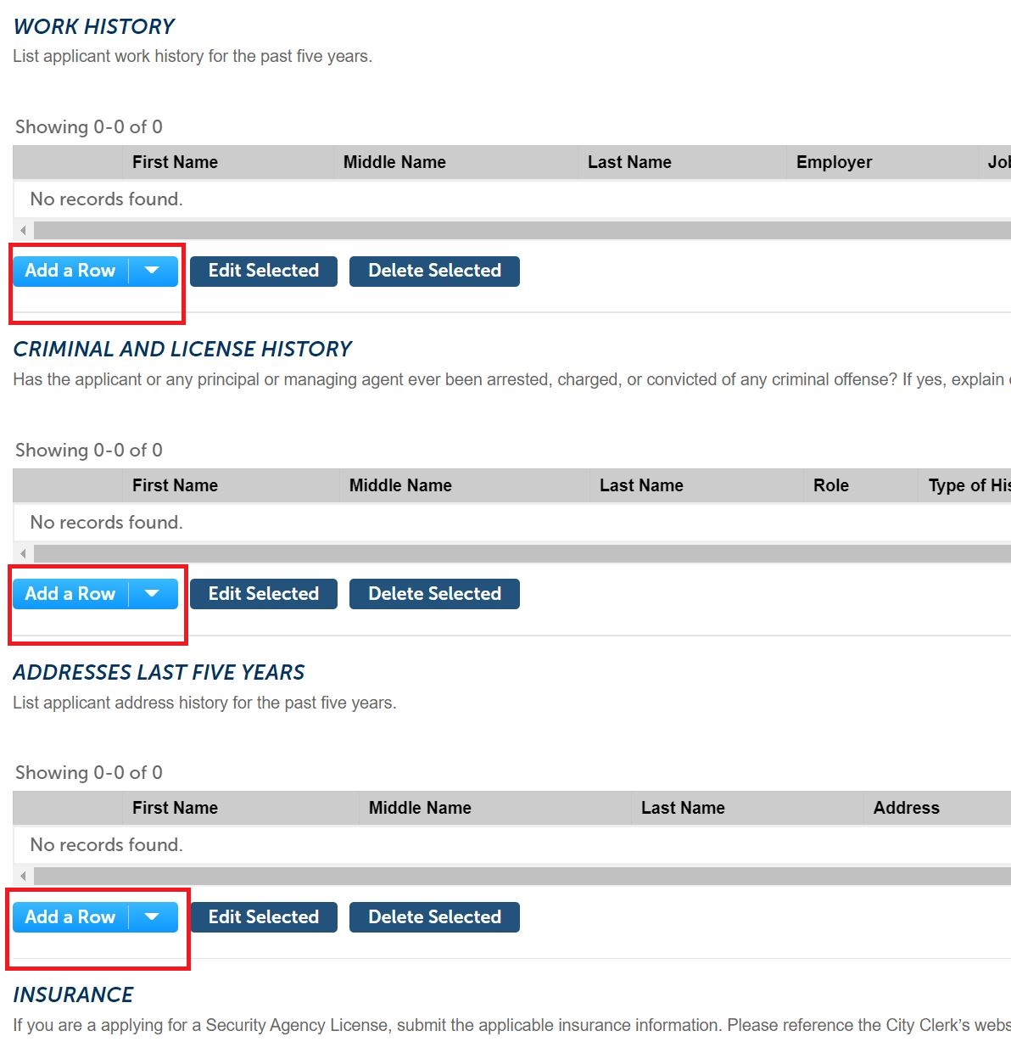

- If applying for a Contract Security Agency License, enter the details of the automobile, general liability, and workers’ compensation policies in the Insurance fields of the Custom Lists workflow. Ensure an entry is provided for each policy. If your agency is not required to carry workers’ compensation by State law, or you are not using vehicles and therefore do not require automobile insurance, type WAIVED in the policy number fields and enter the policy expiration date as 01/01/2001.

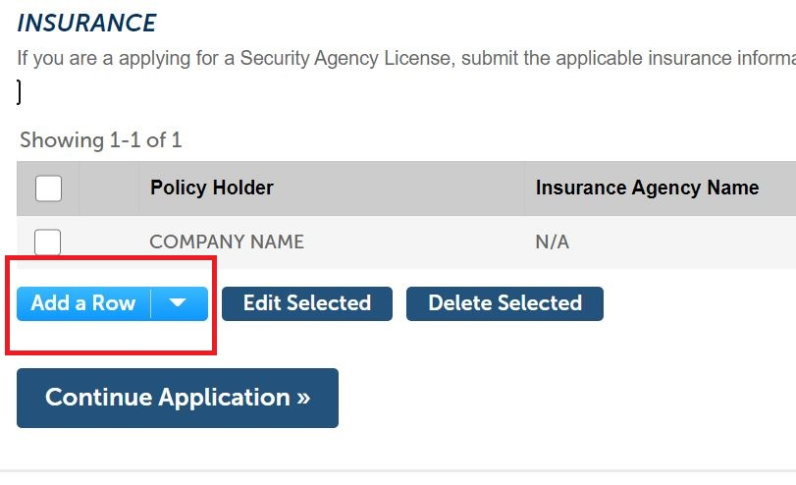

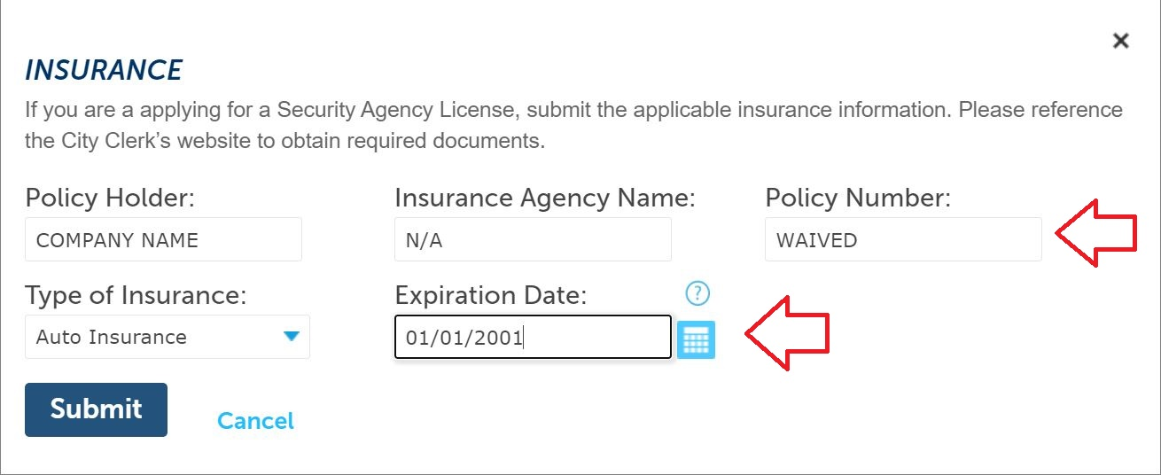

- In step 2 of the workflow, click Add to attach all required documentation. For Security Agency Licenses, attach the color photographs of the front and back of the uniforms, ensuring all badges and patches are legible and compliant with City Code; the color photographs of both sides of the security vehicles, ensuring the verbiage is compliant; the Secretary of State Trade Name Registration and/or Certificate of Good Standing; the insurance Acord documents; and any other required documentation.

For Private Security Guard Licenses, attach the Request for Issuance, ensuring it is dated within the last 30 days and was completed in its entirety by an authorized manager for the employing security agency; all applicable training certificates; the Lawful Presence Affidavit, ensuring only ONE option was checked on the form; and any other required documentation.

Attachments are required. Once all necessary documents have been uploaded, click Continue Application to move forward to Step 3.

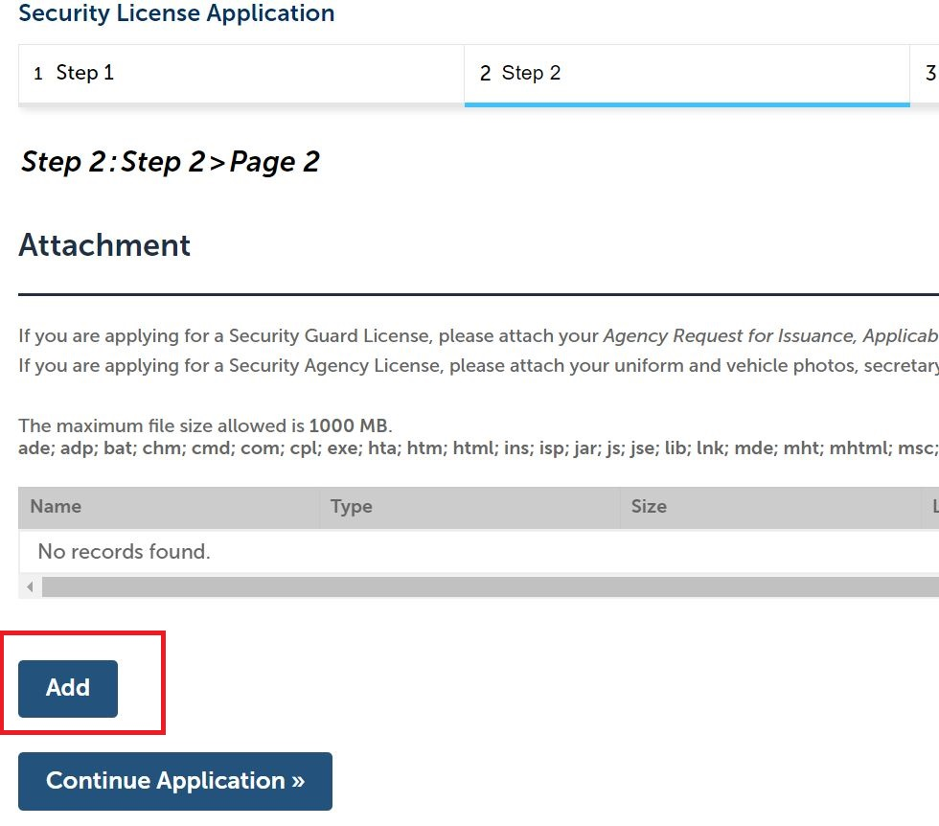

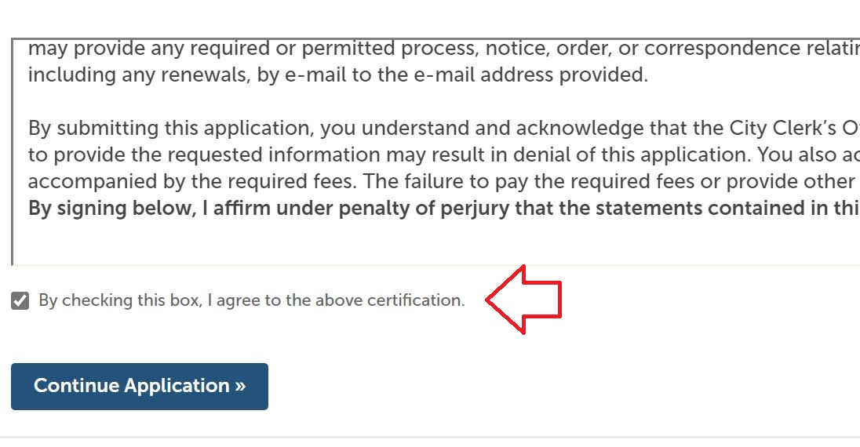
- In step 3 of the workflow, review all information for accuracy. At the bottom of the page, read the language in the certification window, and check the box below it to confirm you understand and agree. Then move forward by clicking Continue Application.

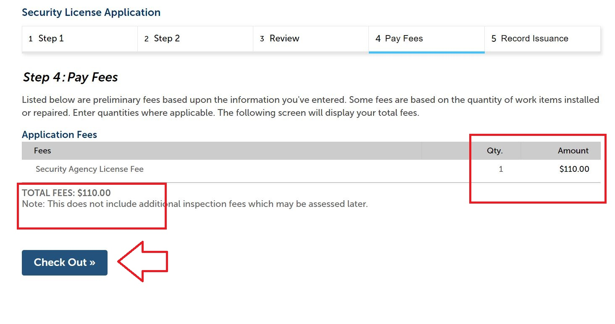
- In step 4 of the workflow, review the payment information for accuracy, and click Check Out. The next screen will review all items in your cart. Click Checkout again to move forward with paying the license fees.

- Submit payment details and click Submit Payment to finalize.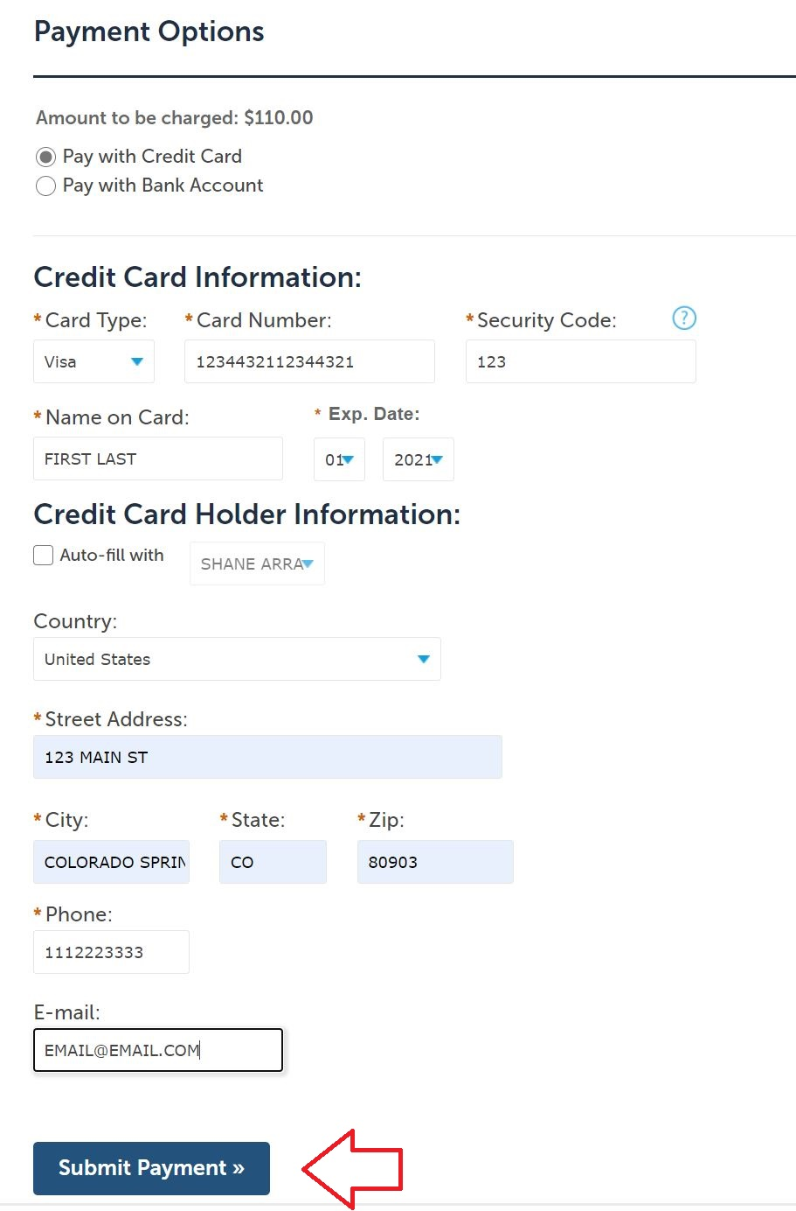
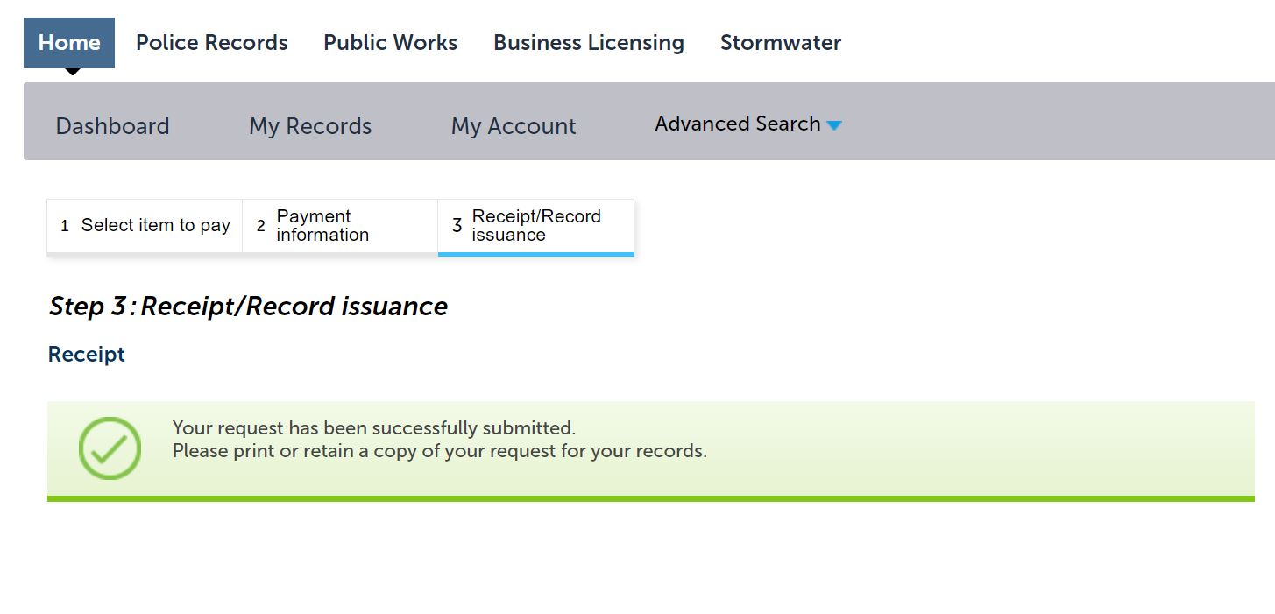
- Once you receive payment confirmation, the application has been sent to the City Clerk’s office for review. Please note, the license is not yet issued at this stage. If any additional information is required, City Clerk general business licensing staff will contact the e-mail address provided for the Applicant. Otherwise, the license will be issued by City Clerk staff and mailed to the address provided for the Applicant.

