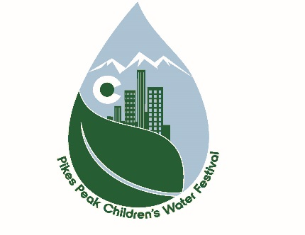
2019 Pikes Peak Children’s Water Festival

Please return this Sponsor form to:
City of Colorado Springs
Water Resources Engineering Division
Attn: Jerry Cordova
30 S. Nevada Avenue, Suite 401
Mail Code 410
Colorado Springs, CO 80903

We would like to be a Children’s Water Festival Sponsor at the following level:
□ Stormwater Sorcerer $1,000+
□ Conservation Connoisseur $500 - $1,000
□ Aquatic Aficionado $100 - $500

Incentives:
• All sponsor levels will have their name/logo printed on the program banner and festival communication.

Please enclose your check payable to:
City of Colorado Springs
Water Resources Engineering Division: Education & Outreach

Contact Name ____________________ Phone ______________ Email _______________________________________________
Company Name _______________________________________
Address ______________________________City____________
State _____ Zip ______________

Thank you for your Support

