Colorado Springs Spring Creek General Improvement District (GID) Dissolution

Background and History

If you received a notice pertaining to dissolution of the Spring Creek General Improvement District (GID), our records indicate your property is included within its boundaries. This GID was created in 1985 and originally issued bonds in 1987 for a principal amount of $5,355,000 to pay for major public improvements associated with the development. These bonds have been paid off and property taxes are no longer collected for this purpose. Therefore, there is no further purpose and need for this GID. State law requires a formal action by the City in order to dissolve it.

Frequently Asked Questions (FAQs)

A: Colorado Revised Statutes § 31-25-625 require that notice be mailed to all property owners in a general improvement district prior to the district being dissolved.
Q: Why did I get this notice?

A: A GID is a separate legal entity created and organized under Colorado Revised Statutes § 31-25-601 et. seq. for the purpose of financing public improvements. GIDs have the authority to levy property taxes and incur debt, typically in the form of bond issues. A City Council (in this case, the Colorado Springs City Council) functions as the board of directors for a GID, by convening separately.
Q: What is a general improvement district (GID)?

A: This GID has met all of its financial obligations and, from the perspective of City Council, has no remaining useful purpose. The GID was originally set up to provide a source of public funding for public improvements, including street, sanitation, water and storm drainage improvements for this development.
Q: Why is this GID being proposed for dissolution?

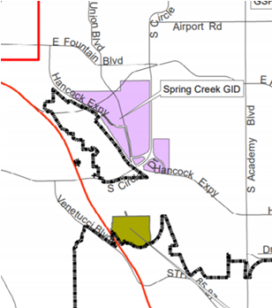

A: There will be no change to your current tax bill related to this GID because this GID has already stopped levying any property taxes as it no longer has any outstanding debt obligations. From about the year 1988 to 2020, a property tax was levied on properties within this GID in order to meet debt obligations.
Q: What impact will this have on my taxes?

A: There would effectively be limited or no financial impact on property owners, because this GID would technically continue to exist but would be entirely inactive. The City would have some limited reporting obligations, which would be eliminated once GID is dissolved. For property owners, having a formal recorded dissolution could make future property transactions less complicated. If not dissolved, the properties would continue to appear as being included in this GID, and this might add some complication to real estate transactions.
Q: What will happen if this GID is not dissolved?

A: No, from the City’s perspective, the only possible reason to keep this GID around would be to theoretically use it for some other future public financing purposes, such as for the financing of new or refurbished public improvements or as a mechanism to provide ongoing maintenance for existing improvements not taken care of by the City or another entity. Under TABOR (Taxpayer’s Bill of Rights), any re-imposition of taxes would require a majority vote of the impacted electors. There already are one or more homeowners associations operating in the Spring Creek to maintain facilities including common areas, small parks and landscaping. If there were ever any interest in a new financing district, the City and any other interested parties could start from the beginning with a full public process.
Q: Are there any reasons to keep this GID around?

A: Carl Schueler, AICP, Comprehensive Planning Manager
City of Colorado Springs Planning & Community Development Department
(719) 385-5391
Carl.Schueler@coloradosprings.gov

Q: Who can I contact if I have additional questions or want to provide comments?

