Pikes Peak Children’s Water Festival
Teacher Guide
Appendix 1 – Supporting Materials

PPLD Water Book List

Optional Activities

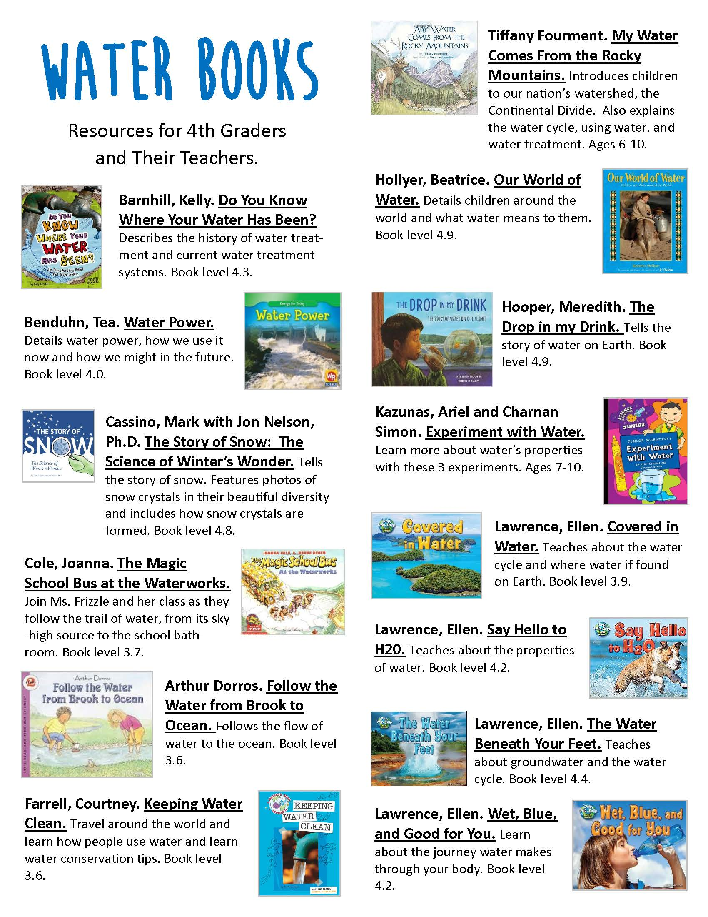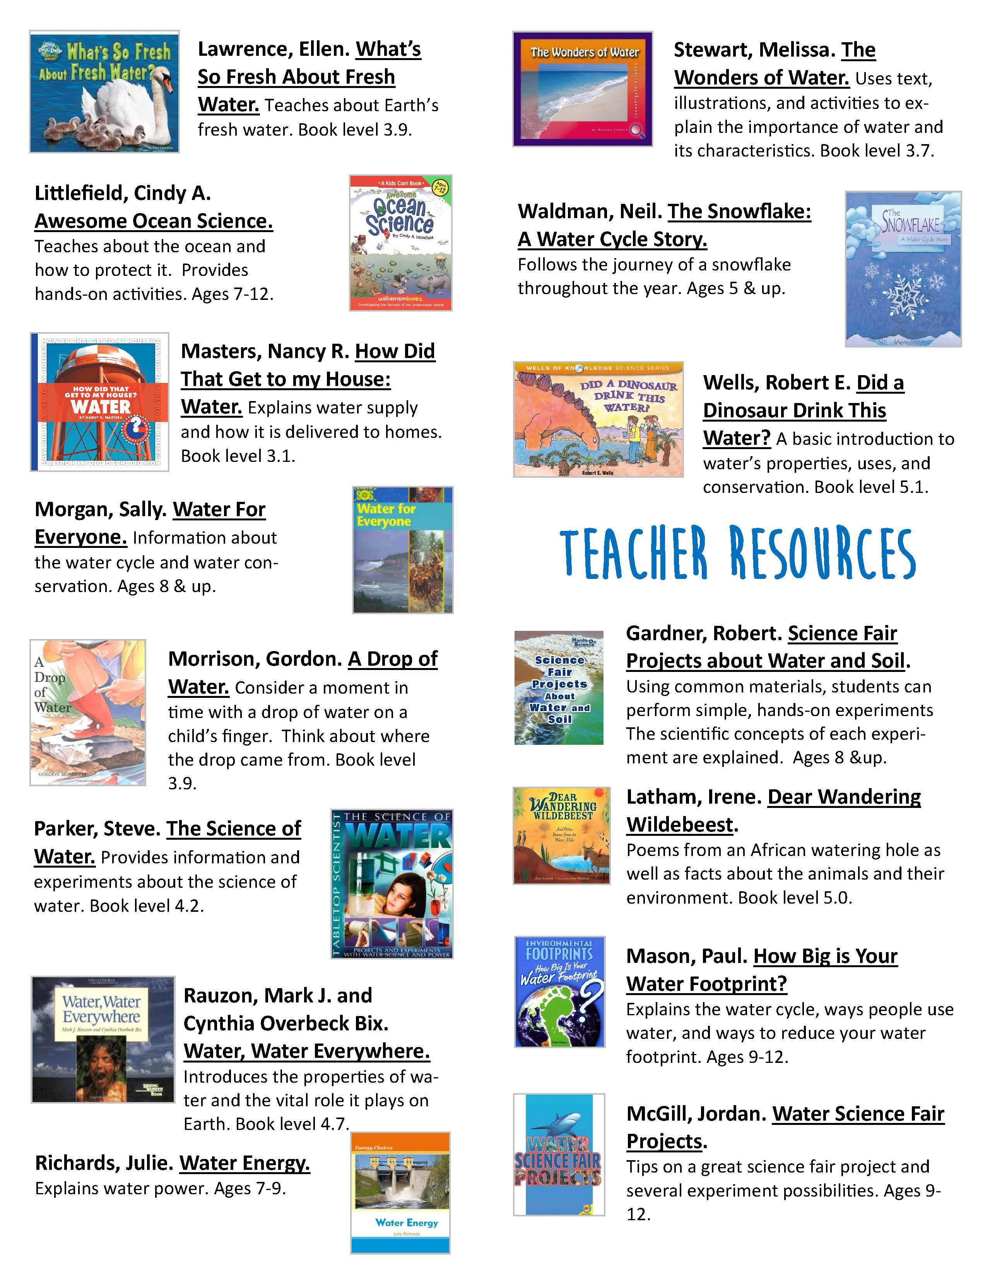
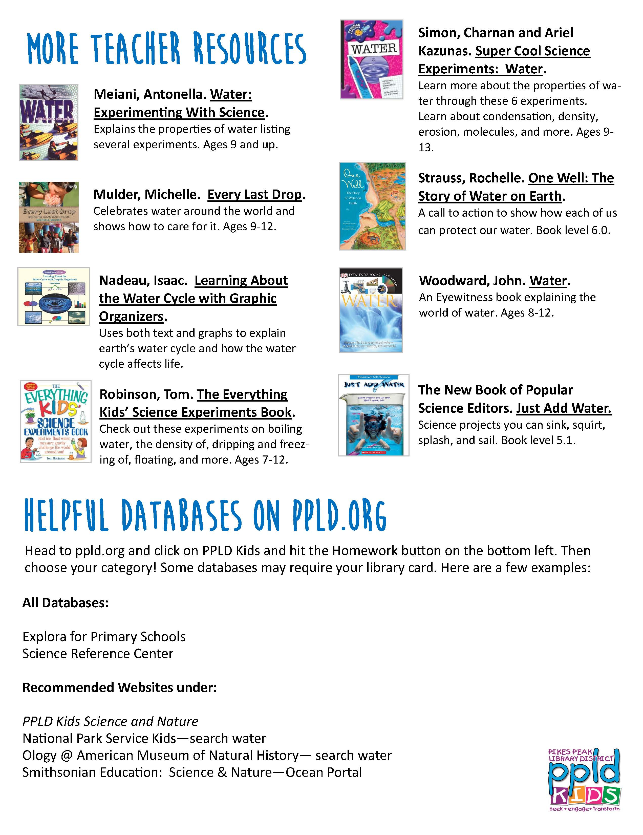
Optional Activities
Clean Up the Water!
Problem:
- Once water has been polluted, how can it be cleaned up?

Materials needed:
Each group of students should have:
—Clear plastic cup filled halfway full of water (represents a lake)
—Vegetable oil (represents car oil)
—Chocolate sprinkles (represents solid animal waste)
—Green sprinkles (represents fertilizer)

Pollution clean-up supplies:
—Small paper plate or bowl
—1 cotton ball
—Spoon
—Toothpick
Procedure:
- Observe how your lake looks at the beginning. Write a sentence in the data collection chart describing how your lake looks.
- Pour the “car oil” into your lake. Observe how this affects your lake. Write a sentence about it.
- Add the “solid animal waste” to your lake. Observe how this affects your lake and write a sentence about it.
- Add the “fertilizer” to your lake. Observe how this affects your lake. Write a sentence about it.
- Discuss ideas of how you might go about cleaning up your lake with the materials provided.
- Now, when the teacher indicates it is time work together with materials provided to clean up your lake. You have 3 minutes! You may not use your hands!
- After you clean up your lake, answer these questions:
- Which waste(s) were you able to clean up completely?
- Car oil b. Solid animal waste c. Fertilizer d. None
- Which waste(s) were you able to partially clean up?
- Car oil b. Solid animal waste c. Fertilizer d. None
- Which waste(s) were you not able to clean up at all?
- Car oil b. Solid animal waste c. Fertilizer d. None
- Are the car oil, solid animal waste and fertilizer point source or non-point source pollutants? _____________________________________________________________________________
Why?____________________________________________________________________________________________________________________________________________________________________________________________________________________.

Clean Up the Water! Data Collection/Observations:

Clean  Lake | _______________________________________________________  _______________________________________________________  _______________________________________________________
Car  Oil | _______________________________________________________  _______________________________________________________  _______________________________________________________
Solid Animal  Waste | _______________________________________________________  _______________________________________________________  _______________________________________________________
Fertilizer | _______________________________________________________  _______________________________________________________  _______________________________________________________

Clean up the Water adapted from materials written by Laurel Laumann, 6th grade Teacher, Mrachek Middle School. Used with permission.
Making Drinking Water
Objective: The students will be able to describe the methods of purifying water as used by the pioneers, as well as those being used today by water treatment facilities.
Background: The pioneers learned to drink from flowing waters and not from still waters. And while water in lakes, rivers and streams often contain impurities that make them look and smell bad, the water could be "cleaned" to make it safer to drink. The pioneers would use citric acid or alum which took suspended particles and allowed them to sink to the bottom of the bucket. Sedimentation or allowing the water to sit for several hours also took out some impurities. Finally, the pioneers would strain the water through material to take out additional nasties. To further purify the water, especially if diseases were suspected, they boiled the water before drinking. Several of these methods are currently used by water companies to treat our drinking water today. The water that is processed comes from lakes, rivers, streams or groundwater and has usually been transferred and stored before processing.
The following steps are typical in a water treatment plant:
Coagulation: To remove dirt suspended in water, powdered alum is dissolved in the water and it forms tiny, sticky particles called "floc" which attach to the dirt particles. The combined weight of the dirt and alum particles becomes heavy enough to sink to the bottom during the next process of sedimentation.
Sedimentation: The heavy particles sink to the bottom and the clear water above the particles pours on to the filtration beds.
Filtration: The clear water passes through layers of charcoal, sand and gravel to remove smaller particles.
Chlorination: The final process where a small amount of chlorine gas is added to kill any bacteria or microorganisms that may be in the water. The pioneers generally boiled their water to kill bacteria and microorganisms.

Materials
(Per group or classroom)
- 1 cup of water with approximately ½ teaspoon dirt. (You can substitute with river or creek water.)
- 2 clear plastic cups holding approximately 10 oz. each.
- 2 pieces of cheesecloth.
- 1 teaspoon powdered alum from the grocery or drug store.

Procedure
- Pass out 1 clear plastic cup that has ½ teaspoon of dirt mixed in the water (or use water from your local river or creek), 2 clear, clean plastic cups and 2 pieces of cheesecloth.
- Have the students add ½ teaspoon of alum and watch the floc form (flocculation). Allow the cup to sit undisturbed for several minutes (sedimentation).
- Have the students hold a piece of cheesecloth (representing the charcoal, sand and gravel filter) over the empty cup. Gently pour the top layer of water from the sedimentation cup into one of the empty cups. Pour the water into the second clean, clear plastic cup using the second, clean piece of cheesecloth to cover the top of the cup. Compare the two pieces of cheesecloth (filtration).
- Discuss with the students the final step necessary to make the water safe to drink (disinfection). How did the pioneers disinfect their water? How do we disinfect our water today?

Extension
Go on a field trip to your local water treatment plant or invite someone from the facility to visit your class. Have students read settler journal entries taking note of references to water quality, quantity and water borne diseases.
Source - Nebraska Groundwater Foundation

Hard Water, Soft Water

Objective: The students will observe, classify and order water samples according to their degree of hardness or softness.
Background: Pure water does not exist, except in the laboratory. When water is considered pure, it is made up of two hydrogen atoms and one oxygen atom-H₂0. But water mixes with many things. A raindrop mixes with minerals in the soil and carries those minerals with it to the groundwater or toward a stream or river. When water has high concentrations of calcium and magnesium (types of minerals), it is known as hard water. When water has low concentrations of calcium and magnesium, it is generally called soft water. Distilled water is water that has been softened.
Hard water can cause problems in plumbing because it deposits minerals in the pipes, causing a buildup which restricts water flow. You can tell if you have hard water at home because it is hard to get a lather when shampooing and bubble sculpting while you're washing dishes by hand isn't possible. Soft water produces more suds and therefore, is better for cleaning. Many people put water softeners in their homes for that reason. This equipment uses salts to remove most of the calcium and magnesium from the tap water.
Materials
- distilled water
- tap water
- bottled mineral water
- salt water
- food coloring
- liquid soap
- 4 empty, clean baby food jars per group (complete with lids)
- 1 eye dropper per group
- paper and pen to record results

Procedure
Divide the students into small groups. Mix a salt water solution using one tablespoon of salt per liter of tap water. Color the tap water red, the distilled water blue, the salt water yellow and the bottled mineral water green. Pour ¼ cup of each water sample into the baby food jars. Add two drops of liquid soap into each sample. Have the students predict which of the samples will suds up more. Have students determine what might affect the amount of suds. Have one student per group record the predictions and results on a sheet of paper. With lids secured, shake each jar for one minute. Encourage the students to use equal force while shaking. Gather the results for further discussion. Explain hard and soft water to the class. Calcium and magnesium cause the soap to separate from the water resulting in little or no suds. In distilled water, these minerals have been removed and it should create suds like crazy.

Extensions
Make a survey and graph the results. Test rain water, melted snow, and lake, creek or pond water and add those to the results. Have the students bring in samples from home and test their own water. Which is cheaper, tap water or softened water? Make a graph of the costs. Have the students run a survey on who uses bottled water and why. Write a letter to a water softener company or have a representative visit the classroom. Try using some water softening salts to soften a hard water sample.

Evaluation
How did the prediction compare to the results? Students should be able to describe the difference between hard and soft water, which is better for cleaning and other benefits of soft water over hard water.
Source - Nebraska Groundwater Foundation

Water Uses Worksheet

There is little danger of North America running out of water. But there is a danger that we will run short of high quality water. You can help by using only as much water as you need. If you study how you use water now, you will be able to find ways to conserve.

Water You Use
Study the chart below. Then keep this sheet with you for one day. Mark it each time you use water. Remember this is an estimate, not an exact measure of how much water you use. Use the average amount given in the second column to do your calculating. For example if you get six drinks of water a day, you would estimate 6 x ¼ = 1 ½ gallons. You would not drink ¼ gallon of water each time you get a drink, but that much could run from the faucet if you let it run to get cold.

How You Use Water | Average Amount | Put a Tick Mark for Each Use | Total Gallons Used
Taking a bath | 30 gallons x |  | =
Taking a shower | 20 gallons x |  | =
Flushing a toilet | 1.6 gallons x |  | =
Washing hands or face | 2 gallons x |  | =
Brushing teeth | ¼ gallon x |  | =
Other (you estimate) | x |  | =

Total inside water used by you in one day __________________

Compare and graph each student's inside use. Determine the similarities and differences. Discuss ways to conserve indoor water. Have the students bring in a utility bill from one of the winter months (January or February works best) and another utility bill from a summer month (July or August). Compare inside and outside water use. Which is greater and why? How can water be saved outdoors?

Extension
Contact your local water conservation specialist to arrange a classroom presentation on water saving devices. Have the students plant a garden with a variety of plants that require differing amounts of water to grow. Measure the water applied to each plant. Take notes on their physical appearances. Research water usage in developing countries. Compare amounts with the student's usage. Have the students carry jugs of water for a day (simulating what many people in developing countries have to do). Discuss changes in attitudes toward water use before and after carrying the jugs.

Source: Nebraska Groundwater Foundation

Plants and Water

Objective: Students will be able to observe and measure the amounts of moisture naturally transpired by desert or drought tolerant and high water requiring plants. Students should be able to define "transpiration" and choose plants that would be low in transpiration based on physical appearance.
Background: What is transpiration? Transpiration is the process by which water vapor escapes from the living plants, principally through the leaves, and enters the atmosphere. All plants store water within their structure. When the temperature surrounding the plant increases sufficiently, the stored water becomes a vapor (gas). Certain plants transpire more than others. The less transpiration, the less water the plant loses, so in arid climates where water is scarce, conservation in the transpiration process is a typical plant adaptation.
There are subtle distinctions between low water demanding plants and desert plants. Desert plants are plants which grow in desert regions. Low water use plants are plants which require a small amount of water. Native plants are all plants naturally occurring in the region being studied and may or may not be low water plants. Drought resistant plants are plants which can survive long periods without water. Drought resistant plants may be native or non-native plants.

Materials
- plastic sandwich bags and ties
- high and low water requiring plants
- liquid measuring devices

Procedure
Examine several common, leafy, green plants and several desert or drought tolerant plants (look in a local gardening book for examples or call your local nursery person for appropriate plant species). Observe their color, form and other physical features. Talk about how much water might be stored in each type of plant and how much water each might require based on their observations.
There are many plant adaptations that allow storage of water and/or reduction in the transpiration rate in desert and/or drought resistant plants.
1. Gray or light colors provide a reflective surface.
2. Wilting during the hot part of the day helps plants to reduce water loss by reducing transpiration.
3. Loss of leaves or leaves closing during the summer or dry spells, allows the plant to go into semi-dormancy.
4. A low ratio of surface area of the plant to volume. (For example, succulents will have thick leaves, pads, or main stems.)
The students will compare the amounts of transpiration between plant species with differing water requirements.
Have the students select various desert or drought tolerant and high water demanding plants. Place a plastic baggie around one or more leaves or each plant. Leave the baggie on the plants for 24 hours. Evaluate the amount of moisture in each plastic bag. Discuss the factors that may influence the amount of water transpired (including leaf and plant structure and color) on evapotranspiration rates. Try the experiment at different times of the year or day vs. night and compare results. The differences in transpiration adaption of desert plants should be apparent.

Extension
Variation of results can be examined by leaving some of the plants in the sun or some in dark closets. Others may be placed in different locations in the classroom. Lead a class discussion; review the differences between riparian plants (plants which grow near water) and drought to tolerant or desert species. Also discuss the distinctions between low water use plants, native plants, drought resistant plants and desert plants.
Discuss how stored water in all living things evaporates into the atmosphere and how humidity is created. Humans keep cool by perspiring or losing water to the air (hydrologic cycle).
Have students figure out the transpiration characteristics of plants in their yards. The transpiration rate of the plants is indicative of water loss to the atmosphere and influences the water requirements of plants.

Source
City of Boulder, Department of Public Works/Utilities

Water Music
Tapes relating to water are readily found in your local library or perhaps your school's music teacher may be of help. You may wish to put on an entire program for the school about water and its importance, using some of this music, original skits, poems, creative writings, etc. done by your class. Enjoy!

Felix Mendelssohn-Becalmed at Sea, The Rivulet
Nicholas Rubinstein-Ocean Symphony
Claude Debussy-La Mer
Vaughn Williams-Sea Symphony
Johannes Brahms-Rain Sonata
Franz Schubert-Water Songs
Maurice Ravel-Jeux d 'eau
Frederick Chopin-The Raindrop
Luigi Cherubini-The Water Carrier
George Frideric Handel-Water Music
The Banks of the Dee-1767 (believed to be the first popular song in U.S.)
Shennandoah-1830's
Daniel Emmett-Dance, Boatmen, Dance
Stephen Foster-Old Folks at Home
Deep River-Negro Spiritual, 1850's
Paul Dresser-On the Banks of the Wabash
Down by the Old Mill Stream-1910
Beautiful Ohio-1918
Jarnes Cavanaugh and Harry Barris-Mississippi Mud
Jerome Kern-Old Man River
Jimmie Rogers-Miss the Mississippi and You
Bob Nolan-Cool Water
Woody Guthrie-Roll on Columbia
Johnny Mercer and Henry Mancini-Moon River
Randy Newman-Burn On
Pete Seeger-Of Time and Rivers Flowing

Water Cycle in a Bag
Three Forms of Water in a Zip-top Bag
Water moves through the water cycle in three different forms—as a liquid, solid or vapor. See all three forms!
Try This!
Add some water and some ice to a zip-top bag. With the opening of the bag almost closed, blow a few puffs of air into the bag. Can you see the water vapor too?
Water Cycle Experiment
Materials:
- handful of dirt
- water
- plastic zip-top bag
- strong tape
- sunny window
Procedure:
- Put the dirt in the zip-top bag.
- Sprinkle a little water on the dirt, just enough to make it moist.
- Close the bag tight and tape it to the sunny window.
- Clean up your mess!
- Watch what happens in the bag.

Sources: Cherry Creek Valley Ecological Park Activity Book, 2006, Parker Jordan Metropolitan District.

Water Cycle Relay

Objective: To physically demonstrate the path a drop of water must take to complete the water cycle.
Background: Discuss the water cycle with the class. Water falls from clouds to the land. Sometimes it falls on mountains, sometimes on plains. Most of Colorado's water falls as snow in the mountains. As it melts, it flows down the mountains into streams where it joins other water drops. These combine to form a river. The river turns and twists until it dumps into the ocean. The sun warms the water on the ocean and it evaporates. The water vapor rises into the sky and forms clouds and the cycle begins again.
Materials
- lots of space
- chalk or masking tape to mark out sites
- balloons or some other means of representing a drop of water

Procedure
Divide the class into groups. For each group, assign one of the paths taken in a water drop's trip through the water cycle to a student: cloud student, mountain student, stream student, river student and ocean student.
Line the students up in the order above – cloud, mountain, stream, river and ocean. Allow plenty of distance between them. You may want the class to design the path to take. It is more fun and challenging if there are things to climb and crawl through along the path. Set up boundaries with cups or pylons so each team knows when to trade off the balloon. Hand each cloud student a balloon and let the relay begin. The cloud student should follow the designated path, then hand off to the mountain student, who then follows a designated path and hands off to the stream student, etc. The cycle is repeated until each student has had a chance to participate or to play each of the roles in the water cycle (round robin).

Extension
Change the situation. What happens to a rain drop that falls directly into the ocean? Or what happens to the water drop in the winter? How does the relay change if the water is absorbed into the soil and goes into the groundwater or is taken up by a plant? If part of the relay is performed on blacktop, have the students draw a landscape along the path.

Source
Nebraska Groundwater Foundation

Water Math

Each citizen of Colorado Springs uses an average of 97 gallons of water each day for all uses (bathing, washing dishes, food preparation, outdoor use etc.) This is about 2,910 gallons per person in a 30-day month. The cost for residential water in Colorado Springs is $4.66 per 1,000 gallons. Source: Colorado Springs Utilities

- How much would the average person pay for one month's water use?

- The Smith family has four people. How much water did they use in one month? How much would their water cost?

- The average price for a gallon of soda pop is about $2.50. How much does 1,000 gallons of soda pop cost? If a gallon of bottled water (bottled in individual bottles) costs about $.90, how much would 1,000 gallons of bottled water cost?

- The Smiths have a faucet that is leaking at the rate of 80 drops per minute. If 1,000 drips equal one eight ounce cup, how long will it take for the faucet to leak one gallon of water? How many cups are leaked in one 24-hour day?

- The Smith's water their lawn three times a week using three hoses. Hose A runs 1 hour, Hose B runs 45 minutes, and Hose C runs for 30 minutes. If each hose delivers 650 gallons of water per hour, how much water do the Smith's use each week for watering? (please note, time is exaggerated and is not accurate for actual watering)

- How much does it cost per week for the Smith's to water their lawn?

- The Smith family learned that they could save water and money by watering their lawn in the evening or early morning hours when the evapotranspiration rate (water lost to the air) was lower. They reduced their weekly water by 1/3! How many gallons of water did they save? How much money did they save?
Pass the Jug

Objective: Students will understand historical and current aspects of water law and gain an understanding of how water rights are allocated in Colorado.
Background: In the mid-nineteenth century, gold and silver were found in the Sierra Nevada and the Rocky Mountain ranges. Miners had an urgent need for water to work their claims. Unfortunately, there wasn’t much water to be found or perhaps it was located far from their claim or the stream didn’t run year round. To promote peace and certainty, the miners developed an approach to water rights that was closely related to mining rights. The first to stake and work a claim owned the mine. The same held true for water rights—development (staking) was followed by use (working). This type of water law became known as the Prior Appropriation Doctrine. As the West was settled, these same principles were applied to agriculture, municipalities and industries.
Water rights are used to allocate or distribute water in an organized and systematic manner. A water right in Colorado is considered a vested right, similar to property rights. Therefore, rights can be bought and sold. It is important to note that it is the right to use the water, not a right to own the water. There are several types of water right doctrines in the United States. Colorado and many of the western states have adopted the Prior Appropriation Doctrine of water law. This law basically says “first come, first served” or “first in time is first in right.” In other words, whoever uses the water first has the prior or first right to the supply of available water. If all the water in a stream is allocated, no new users will be allowed. Water rights are given an appropriation date (the older the date, the more senior and usually more valuable the right). Each right specifies the amount or quantity of water that can be used, a description of uses (irrigation, municipal uses etc.) and location of those uses. If a holder of a water right does not use or exercise that right within a certain period of time (multiple years), she or he risks loss or abandonment of those rights.
In recent years, many changes have occurred that have added new dimensions to water rights and water allocation programs. Irrigated agriculture is a large consumer of water and often holds the more senior rights. Individuals and corporations invest millions of dollars in irrigation systems to produce food for our nation. Cities also need water to meet the needs of residents, businesses and industries. Water for recreation and fish and wildlife is receiving growing attention. Many communities depend on water resources for energy production. In response to these demands, policy makers are being pressured to reshape traditional water allocation patterns.

Materials
- 3-5 oz. cups (initially one per student)
- water jug (filled)
- funnel
- water user cards (copy and cut)
- food coloring
- salt or sugar
- ice cubes

Procedure
Arrange the students’ seats in rows or around a table. Pass out the cups. Starting at one end, have each student fill their cup and pass it on to the next student. There should not be enough water to fill all the cups. Ask students to express how they feel (those who received water and those who did not). Discuss what might happen during a drought, flood or normal precipitation year. Have the students come up with a plan to redistribute the water and play the game again, observe the results. Empty the cups back into the jug.
Now the students will simulate how water is allocated in Colorado. Read the description of the Prior Appropriation Doctrine in the Background section of this activity. Randomly pass out the cards. Explain that these cards represent a water right. The rights are numbered in the upper left-hand corner. The student with number 1 was the first to move into the area and acquire a right to use the water, the student holding the number 2 card the second, etc. Pass out additional cups if needed.
Each student should read aloud their card and pour, in order of seniority (1st, 2nd, 3rd, etc.), their rights (water) into their cups. When water runs out have the students express their opinion about this system. How would they alter it? Are there ways to redistribute the water without harming another's water rights? Increased storage with delayed releases, temporary lease agreements between farmers and municipal users and conjunctive groundwater and surface water use are examples of ways to redistribute the water without negative impacts to individual water rights.

Extension
To simulate fluctuations in stream flow from year to year, change the amount of water in the jug. To demonstrate how pollution affects water users, add a drop of food coloring to those activities that may have an impact on quality. Use sugar or salt to represent invisible pollutants. Have the students list how water quantity impacts water quality. Add ice cubes to extend the amount of time water is available for consumption. How does this relate to snow pack? What happens to stream flow when the snow pack melts? Allow the students to buy or sell part or all of their water rights. What are the social and economic effects on the individuals or on the town?
The book “Water Rights in a Nutshell” by David Getches further explains the Prior Appropriation Doctrine as well as the other types of water laws in the United States. After reviewing the different types of Doctrines, have the students discuss the relationship between climate and water law. Would the Riparian Doctrine used in the Eastern United States work in Colorado?
Source: Project WET; 1993 The Watercourse and Western Regional Environmental Educational Education Council (WREEC)
Number 1  I am a descendent of the first homesteader that moved into the area. I own a dairy goat farm and grow alfalfa.  Use 2 cups | Number 2  My ancestor was on the way to California during the great gold rush but got distracted by the flowers. While picking daisies, she found a huge deposit of copper ore and started a copper mining company. My family runs this lucrative operation.  Use 1 1/2 cups
Number 3  My great, great-grandmother came out to teach the children of the copper miners. I still live on the property she bought and need water for personal needs.  Use ½ cup | Number 4  I represent a small community of families who work in the mine. We use water for domestic and irrigation purposes. Our water needs may grow as the town grows.  Use 3 cups
Number 5  My grandparents left their farm in Iowa to start a farm in Colorado. The crops I grow helps to meet the needs of our community. My grandfather is still living and resists using modern farming practices.  Use 5 cups | Number 6  To avoid the competition in the big city, my father moved his coat hanger factory to this growing community. The industry provides a means of income for community members.  Use 2 cups
Number 7  I represent a hydroelectric company that is situated upstream of the town. The water the plant uses passes through the dam to generate electricity. (Show this by pouring water back into the jug.)  Give 3 cups | Number 8  I represent a town that grew as more people escaping the city moved to the countryside. Consequently, our town has become a city. We use water for domestic and irrigation purposes.  Use 3 cups
Number 9  I am a high tech farmer who has moved in to supply food to the growing community.  Use 2 cups | Number 10  I have decided to start an industry that I think meets a growing need: shoulder pad storage racks.  Use 1 cup
Number 11  I am a fourth generation rancher. I use the water for irrigating pastures and watering stock.  Use 1 cup | Number 12  I own a ski resort. The money from tourists brings in a lot of revenue to our town. I need to store the water so I can make snow early in the season or in case of low snowpack.  Use 3 cups
Number 13  I am an organic gardener. I grow pesticide free produce for the community.  Use 2 cups | Number 14  I represent a local naturalist society. I use the water for fish and wildlife benefits.  Use 1 cup
Number 15  I represent the local flood control agency. I manage a dam that contains flood waters. I do not have to have a water right to store flood waters. My dam protects people and property downstream. The reservoir is used by fishermen and boaters. (This is represented by pouring water back into the jug.)  Give 2 cups | Number 16  I am a representative of the State of Nebraska. Our interstate compact with Colorado states that you will give us a certain quantity of water at the state line.  Use 2 cups
Number 17  I represent a local resort owner. I need water in the reservoir to keep my paying customers happy. While I do not own any water rights, I have an interest in water management.  Use 2 1/2 cups | Number 18  I represent the country of Mexico. We are downstream of your country. In order to assure water for my country's use, we entered into an international compact. The United States must deliver a certain amount of water at the border to ensure smooth relations between our countries.  Use 3 cups

Other Ideas and Activities

- Prepare a bulletin board with some of the students’ work during this unit. You may want a board displaying the uses of water, a section with newspaper and magazine clippings of water issues, photos of how water and living things are related or one about the water cycle.

- Have the class put together a shadow box or diorama about water.

- Have them write and perform a water play or puppet show for younger students.

- Take an erosion hike and spot examples of water damage, either natural or human made.

- Study water stories of the Native Americans or of people from other lands.

- Have the class develop their own classroom water laws and penalties, e g., forgetting to turn off water “costs” a recess period; letting the water get cold before drinking “costs” a conservation poem, etc.

- Have the class put together a saving water resolution and have it signed by the principal.

- Set up a display in the school cafeteria showing how water can be conserved by even the youngest students.

- Have a poster contest on saving water.

- Have the students study the source of their water supply. Is it in danger of being polluted? Study any polluted lakes, rivers or streams in your area. What are the effects that can be seen? What about those we don't see?

- Have a PR campaign with the students. Send letters to the editor, design posters and bumper stickers or write and present news stories about a water topic.

- See about volunteering, as a class, at a local lake or recreation area to do cleanup, etc.

- Put together a People's Water Court and stage a mock trial for a major water polluter or waster.

- Study the major rivers in Colorado.

- Write a letter to the city officials in a major metropolitan area that uses surface water as its major supply of water. Colorado Springs, Aurora, Denver and Thornton are a few. Study surface water sources in other parts of the world.

- Put together an aquarium of Colorado fish.

- Study water pollution and the types of pollution - disease carrying agents, inorganic and organic chemicals, plant nutrients, sediment, heat, radioactive substances, oxygen demanding wastes and synthetic organic chemicals.

- Develop an environmental and/or water textbook of clippings from newspapers, magazines, etc. Keep them in a loose-leaf notebook (Don't forget cartoons!). Be sure articles are labeled with the newspaper's name and date. Have the students write a summary or interpretation of the articles.

- Make a sediment dam in a bottle using an empty pop bottle. Pour in a few tablespoons of soil and the rest with tap water. Shake the bottle to show how sediment mixes with water. When left alone for several hours, the sediment will settle to the bottom just like it does in a reservoir.

- Have an engineer visit and discuss how and why dams are built. Ask for a cross section of the dam.

- Set up a learning center using the worksheets in this packet.

Source
City of Aurora; Nebraska Groundwater Foundation

